UNIT – I

HTML
Basic HTML: Document body, Text, Hyper links, adding more formatting, Lists, and Tables using images.
More HTML: Multimedia objects, Frames, Forms towards interactive, HTML document head detail
……………………………………………………………………………………………………………………..

Basics of HTML

HTML stands for Hypertext Markup Language. It is used to display the document in the web browsers. HTML pages can be developed to be simple text or to be complex multimedia program containing sound, moving images and java applets. HTML is considered to be the global publishing format for Internet. It is not a programming language. HTML was developed by Tim Berners-Lee. HTML standards are created by a group of interested organizations called W3C (World Wide Web consortium). In HTML formatting is specified by using tags. A tag is a format name surrounded by angle brackets. End tags which switch a format off also contain a forward slash. Points to be remembered for HTML tags:

- Tags are delimited by angled brackets.

- They are not case sensitive i.e., <head>, <HEAD> and <Head> is equivalent.

- If a browser not understands a tag it will usually ignore it.

- Some characters have to be replaced in the text by escape sequences.

- White spaces, tabs and newlines are ignored by the browser

Features of HTML

- It is a very easy and simple language. It can be easily understood and modified.
- It is very easy to make effective presentation with HTML because it has a lot of formatting tags.

- It is a markup language so it provides a flexible way to design web pages along with the text.

- It facilitates programmers to add link on the web pages (by html anchor tag) , so it enhances the interest of browsing of the user.

- It is platform-independent because it can be displayed on any platform like Windows, Linux and Macintosh etc.

- It facilitates the programmer to add Graphics, Videos, and Sound to the web pages which makes it more attractive and interactive.

Advantages of HTML:

- First advantage it is widely used.

- Every browser supports HTML language.
- Easy to learn and use.
- It is by default in every window so you don't need to purchase extra software.

Disadvantages of HTML:

- It can create only static and plain pages so if we need dynamic pages then HTML is not useful.

- Need to write lot of code for making simple webpage.
- Security features are not good in HTML.

- If we need to write long code for making a webpage then it produces some complexity

₁ Prepared By K.L.RAJU

Structure of HTML Program

All HTML documents follow the same basic structure. They have the root tag as <html>, which contains <head> tag and <body> tag. The head tag is used for control information by the browser and the body tag contains the actual user information that is to be displayed on the screen. The basic document is shown below.

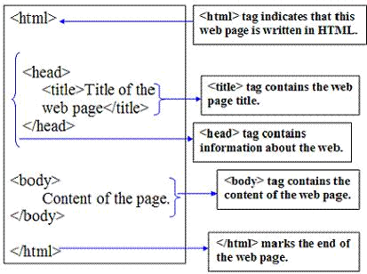

<html> tag:

The <html> tag encloses all other HTML tags and associated text within your document. It is an optional tag. You can create an HTML document with this tag and your web browser can still read it and display it. But it is always a good form to include the start and end tags.

<head> tag:

This tag comes after the HTML start tag. It contains <title> tag to give the document title that displays on the browsers title bar at the top.
Example: <title>tutorialtpoint.net</title>

The <head> also consists of <meta> tag.

- The <meta> tag provides metadata about the HTML document. Metadata will not be displayed on the page, but will be machine parable.

- Meta elements are typically used to specify page description, keywords, author of the document, last modified and other metadata.

- The metadata can be used by browsers (how to display content or reload page), search engines (keywords), or other web services.

Example:

<head>
<meta charset="UTF-8">

<meta name="description" content="Free Web tutorials">

<meta name="keywords" content="HTML, CSS, XML, JavaScript"> <meta name="author" content="John Doe">

<meta name="viewport" content="width=device-width, initial-scale=1.0"> </head>
₂ © Prepared By K.L.RAJU

<body> tag:

This tag contains all the text and graphics of the document at which all the HTML tags that are used for control and formatting of the tag. The actual content of the webpage are placed in the body section. The tag consists of various attributes. They are bgcolor, link, alink, vlink, text.

Example: <body bgcolor=”read” alink=”blue” vlink=”yellow”>

Program: Write a HTML program to display simple welcome message.

<html>

<head>
<title> Basic HTML document </title>

</head>
<body>

<h1> Welcome to the world of Web Technologies</h1> <p> A sample HTML program </p> </body>

</html>

Output:
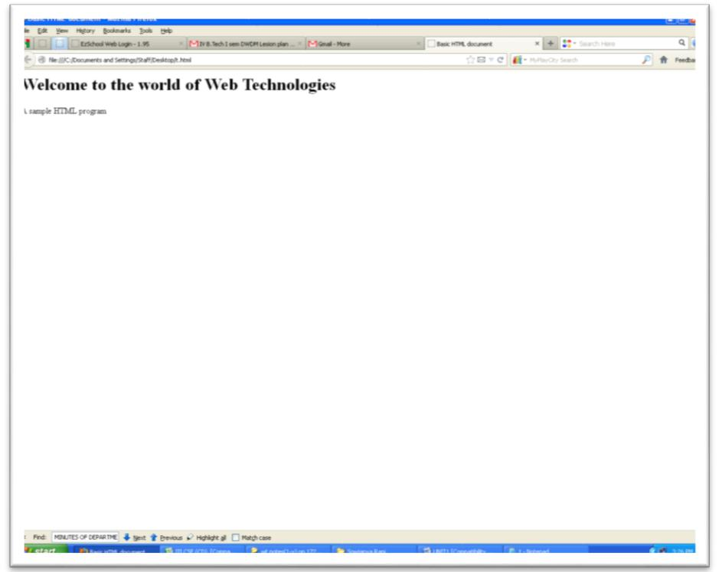

₃ Prepared By K.L.RAJU

1. Document Body

The document / webpage consist of plenty of tags which are used to describe the content of the page. In HTML, document is structured as blocks of text, each of which can be formatted independently. A block has no meaning outside of a particular document.

The two major blocks of text in HTML document are the paragraph and heading. All most all text and images in your document will be part of either a heading or a paragraph.

The HTML paragraph tag (<p>):

HTML paragraph or HTML <p> tag is used to define a paragraph in a webpage. Let's take a simple example to see how it works. It is a notable point that a browser itself adds an empty line before and after a paragraph.

Syntax: <p [align=”left” | “center” | “right”]>……. </p>

Example:

<html>
<body>
<p>
This paragraph
contains a lot of lines

in the source code,
but the browser
ignores it.
</p>
<p>
This paragraph

contains a lot of spaces
in the source code,

but the browser
ignores it.
</p>
<p>

The number of lines in a paragraph depends on the size of the browser window. If you resize the browser window, the number of lines in this paragraph will change. </p>

</body>
</html>

₄ – Prepared By K.L.RAJU

Output:

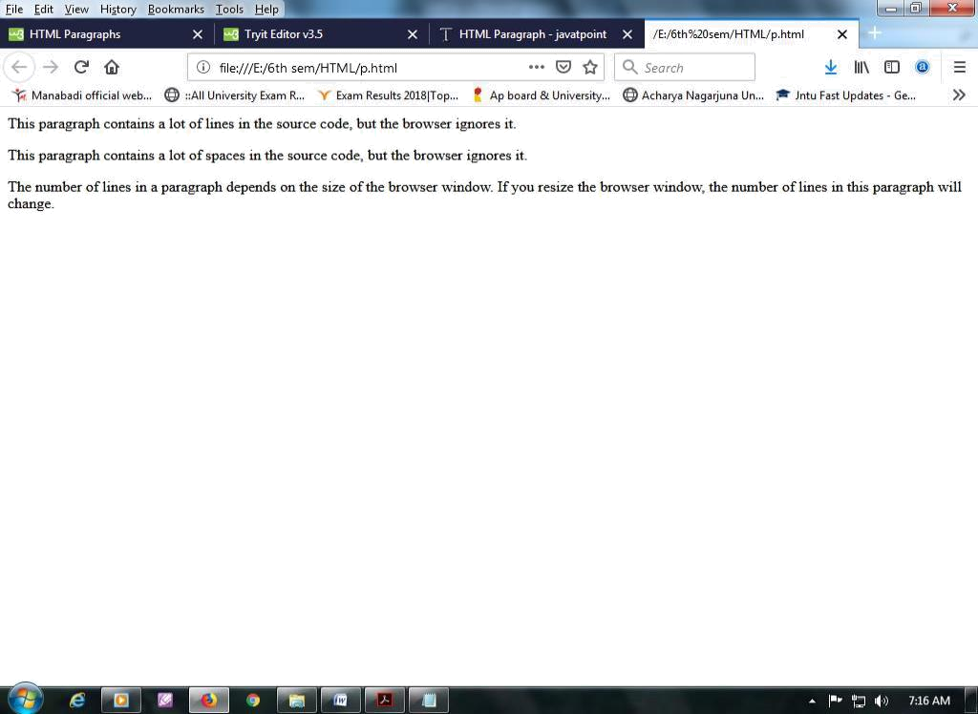

Note: If you put a lot of spaces inside the HTML <p> tag, browser removes extra spaces and extra line while displaying the page. The browser counts number of spaces and lines as a single one.

HTML Heading tags:

A HTML heading or HTML h tag can be defined as a title or a subtitle which you want to display on the webpage. When you place the text within the heading tags <h1>.........</h1>, it is displayed on the browser in the bold format and size of the text depends on the number of heading.

There are six different HTML headings which are defined with the <h1> to <h6> tags.

h1 is the largest heading tag and h6 is the smallest one. So h1 is used for most important heading and

h6 is used for least important.

Syntax:

<h1 [align=”left” | “center” | “right”]>……. </h1>

<h2 [align=”left” | “center” | “right”]>……. </h2>

<h3 [align=”left” | “center” | “right”]>……. </h3>

<h4 [align=”left” | “center” | “right”]>……. </h4>

<h5 [align=”left” | “center” | “right”]>……. </h5>

<h6 [align=”left” | “center” | “right”]>……. </h6>

₅ – Prepared By K.L.RAJU

Example: HTML code to implement heading tags.

<html>

<head> <! -- This page implements heading html tags --> <title> My sample web page </title>

</head>
<body >

<h1>heading level 1</h1>
<h2>heading level 2</h2>
<h3 align="center">heading level 3</h3>

<h4 align="right">heading level 4</h4>

<h5 align="left">heading level 5</h5>

<h6>heading level 6</h6>
</body>

</html>

Output:

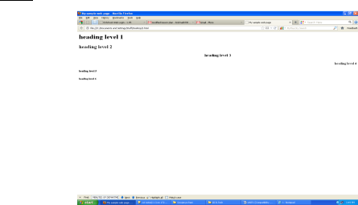

HTML Horizontal line tag (<hr>):

<hr [align=”left” | “center” | “right”] [size=”n”] [noshade] [width=”nn %”]>

- This places a horizontal line across the screen. These lines are used to break up the page and give it a little structure.

- The options determine how the rule will be displayed. It can be aligned but by default is centered on the screen.

- The size option specifies the thickness of the rule in pixel.

- Noshade draws the rule as single thick line rather than giving it the default three dimensional appearances.

- The width of the line is best given as percentage of the available screen size.

₆ – Prepared By K.L.RAJU

  - The percentage length should be placed inside quotes.

- Text or Text Formatting

The text on an HTML page can be altered in a number of ways: The actual font used can be changed to attempt to force the browser to use a specific font and the look of the text can be changed for emphasis.

HTML Formatting is a process of formatting text for better look and feel. There are many formatting tags in HTML

1. base font: This specify format for the basic text but not the headings.

Use: <basefont size=”10”>

2. font tag: This sets font size, color and relative values for a particular text.

Use: <font size=”10” color=”#f1f2f3”>

3. bold tag: This tag is used for implement bold effect on the text

Use: <b> ……. </b>

4. Italic tag: This implements italic effects on the text.

Use: <i>…….</i>

5. strong tag: This tag is used to always emphasized the text

Use: <strong>……….</strong>

6. tt tag: This tag is used to give typewriting effect on the text

Use: <tt>……..</tt>

7. sub and sup tag: These tags are used for subscript and superscript effects on the text.

Use: <sub> ……….</sub>

Use: <sup>………..</sup>

- Break tag: This tag is used to the break the line and start from the next line.

Use: <br>

- Preformatted tag: used to display ready-formatted text on the webpage.

Use: <pre> ……….. </pre>

- &amp &lt &gt &nbsp &quot: These are character escape sequence which are required if you want to display characters that HTML uses as control sequences.

₇ – Prepared By K.L.RAJU

Example: < can be represented as &lt.

- <strike> tag: it puts a line strike through the center of the text, crossing it out. Use: <strike> This is striking text </strike>

- <mark> tag: used to highlight the text.

Use: <mark> this line is so important </mark>

Example:

<html>

<head><title> common tags </title></head>

<body>

<h1>Web Technology</h1>

<p align="center"><br>

<b>Bolded text</b><br>

<strong>Strong</strong><br>

<u>underline</u><br>

<i>Italic</i><br>

<em>same as Italic</em><br>

<b><i><u>welcome</u></i></b><br>

<strike>This is a Strike</strike><br>

<s>same as above</s><br>

<mark> this is important text</mark> <br>

a<sup>2</sup>+ b<sup>2</sup>+2ab <hr>

h<sub>2</sub>o

<tt>tele text</tt>

<font face="Arial" size="3" color="red">

</body>

</html>

₈ – Prepared By K.L.RAJU

Output:

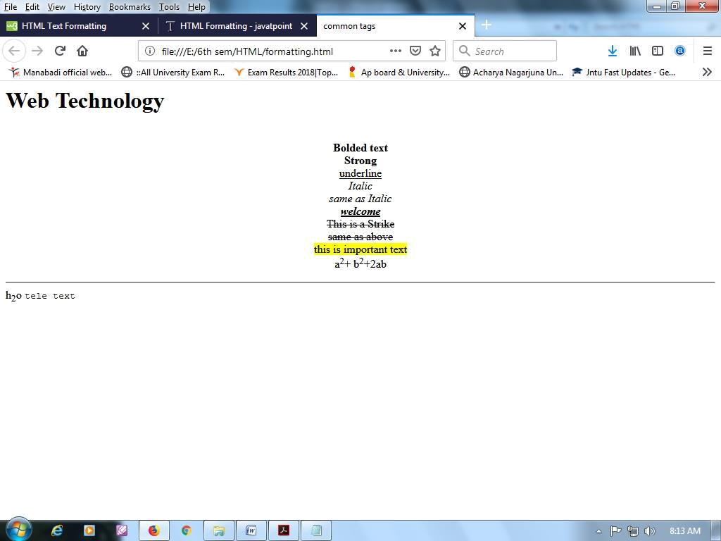

3. Hyper links

Hyper link is a string of clickable text or a clickable graphics that point to another webpage or document.

In HTML, the hyperlinks will be prepared by using anchore tag <a> ……. </a>. It has the following
syntax

<a href=”URL address” target=”frame address” name=”section name” shape=”circle | rectangle”> … </a>

In the above statement

href – name of the source file

target --- name of the frame where we divide the webpage into frames name --- provides the section for the webpage

Shape --- provides the shape of the area in the image.

HTML Link Colors

By default, a link will appear like this (in all browsers):
- An unvisited link is underlined and blue

- A visited link is underlined and purple

₉ – Prepared By K.L.RAJU

- An active link is underlined and red

There are four types of hyperlinks

- Clickable text hyperlinks
- Clickable Image hyperlinks

- Mail to hyperlinks
- Intra document hyperlinks

Clickable text hyperlinks

It contains the address of the referenced document, a piece of text to display as the link and closing tag. The general form is

<a href=”address”> ……. </a>

Example: <a href=”www.anuupdates.org> click here to get all Nagarjuna university updates</a>

Clickable Image hyperlinks

It contains the address of the referenced link as an image i.e. we nested the image with in the anchor tag.

The basic form is

<a href=”address”>

<img scr=”image address” width=”n” height=”n”></img>

</a>

Example:

<a href=”www.manabadi.co.in/results”>

<img scr=”results.jpeg” width=”50” height=”50”></img>

</a>

In the above example, the webpage displays an image, when you click on the image, it will bring you to another page specified in the address filed.

Mail to Hyperlink

It is possible to add a mail to hyperlink to a webpage. This provides a convenient method to send the e-mail. The general form is

<a href=mailto:admin@gmail.com>contact us</a>

When the user clicks on the text contact us, a mail dialog box will be launched and the “To” filed will be filed the address admin@gmail.com . The user has to complete the remainder of the message

₁₀ – Prepared By K.L.RAJU

Intra document hyperlink or linking to a specific section

The Intra document linking can be done through <a> tag with the help of “name” attribute. It allows us to create a hyperlink to any part of the document i.e., we can link a specified section of the webpage. The basic form is

<a href=”#target”> …… </a>

Example:

<html>

<head>

<title> Intra document hyperlinking</title>

</head>

<body>

<p><a href="#news">Go to the News</a></p>

<h1>Welcome</h1>

<p>This paragraph welcomes you.</p>

<h2>About</h2>

<p>This paragraph talks about us.</p>

<br>

<h2><a name="news">News</a></h2>

<p>This is the section your link will go to.</p>

</body>

</html>

4. Adding more formatting

More formatting can be applied to a webpage by adding colors and images, lists, tables, sounds, applets and animations.

₁₁ ©– Prepared By K.L.RAJU

5.Lists or <li> tag in HTML

One of the most effective ways of structuring a web site is to use lists. Lists provides straight forward index in the web site. HTML provides three types of list i.e., bulleted list, numbered list and a definition list. Lists can be easily embedded easily in another list to provide a complex but readable structures. The different tags used in lists are explained below. There three types of list

- Unordered list or Bulleted list
- Ordered list or Numbered list
- Definition list

<li> …..</li>

The ordered (numbered) and unordered (bulleted) lists are each made up of sets of list items. This tag is used to write list items

Unordered list or Bulleted list

<ul type=”disc” | “square” | ”circle” > …..</ul>

This tag is used for basic unordered list which uses a bullet in front of each tag, everything between the tag is encapsulated within <li> tags.

<html>
<head>

<title> Unordered list or Bulleted list </title>
</head>

<body>
<h2> Unordered list or Bulleted list demo </h2>

<ul>
<li>www.w3schools.com </li>
<li>www.javatpoint.com </li>

<li>www.tutorialspoint.com </li>
</ul>

<ul type="square">
<li>HTML</li>

<li>Java</li>
<li>JavaScript</li>
<li>SQL</li>

</ul>
</body>

</html>

₁₂ – Prepared By K.L.RAJU

Output:
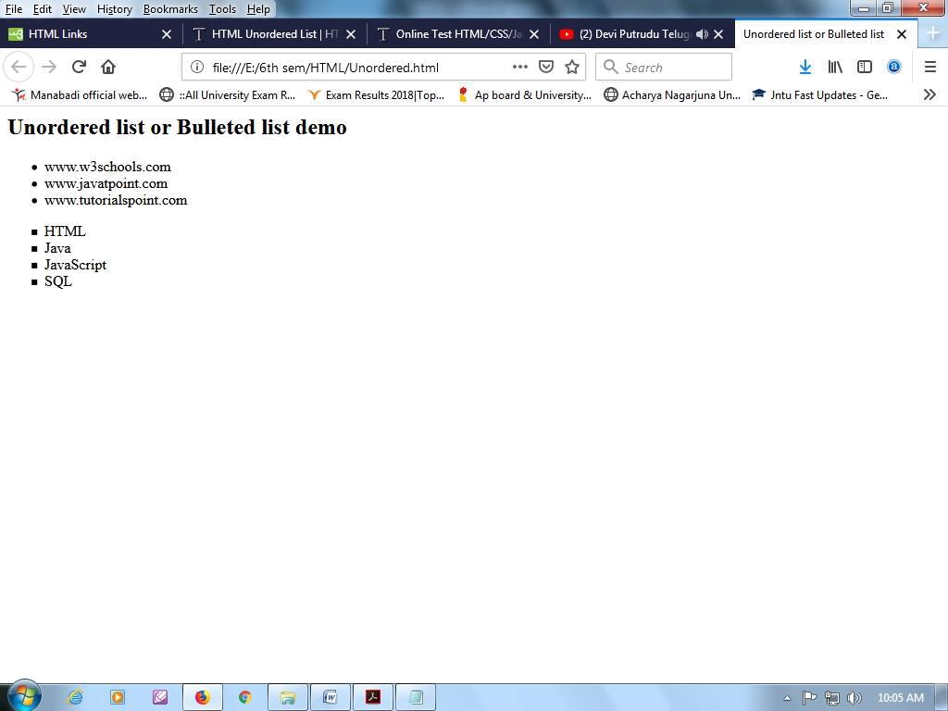

Ordered list or Numbered list

<ol type=”1” | ”a” | “I” start=”n”>…..</ol>

This tag is used for unordered list which uses a number in front of each list item or it uses any element which is mentioned in the type attribute of the <ol> tag, start attribute is used for indicating the starting number of the list.

<html>
<head>

<title> ordered list or Numbered list </title>
</head>

<body>
<h2> ordered list or Numbered list demo </h2>
<ol>

<li>www.w3schools.com </li>
<li>www.javatpoint.com </li>

<li>www.tutorialspoint.com </li>
</ol>

<ol type="a">
<li>HTML</li>

<li>Java</li>
<li>JavaScript</li>
<li>SQL</li>

</ol>
</body>
₁₃– Prepared By K.L.RAJU

</html>

Output:
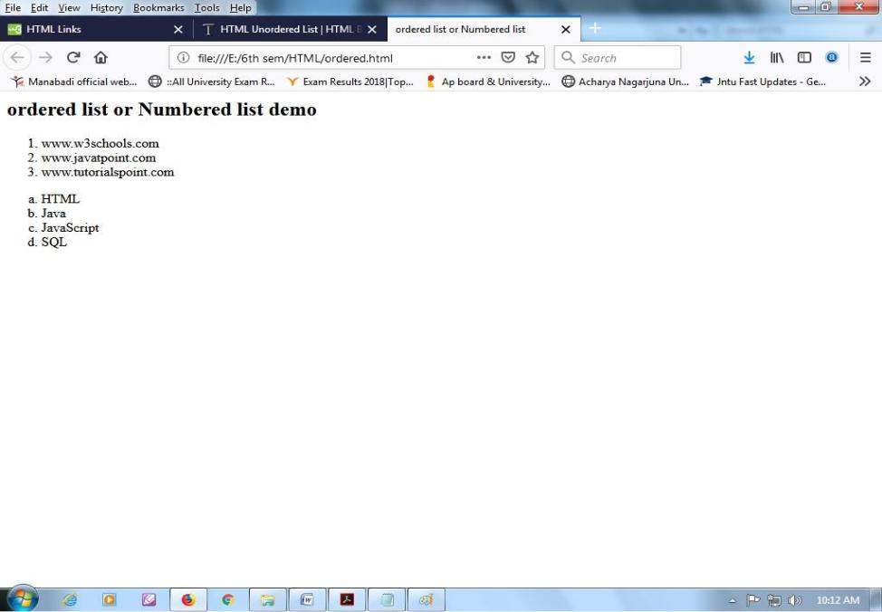

Definition List

<dl>….. </dl>

This tag is used for the third category i.e., definition list, where numbers or bullet is not used in front of the list item, instead it uses definition for the items.

<dt>…..</dt>

This is a sub tag of the <dl> tag called as definition term, which is used for marking the items whose definition is provided in the next data definition.
<dd> …. </dd>

This is a sub tag of the <dd> tag, definition of the terms are enclosed within these tags. The definition may include any text or block.
Example:

<html>
<body>

<dl>
<dt>HTML</dt>
<dd>is a markup language</dd>

<dt>Java</dt>

<dd>is a programming language and platform</dd> <dt>JavaScript</dt>
<dd>is a scripting language</dd>

<dt>SQL</dt>
<dd>is a query language</dd>

</dl>
</body>
</html>
₁₄ – Prepared By K.L.RAJU

Output:

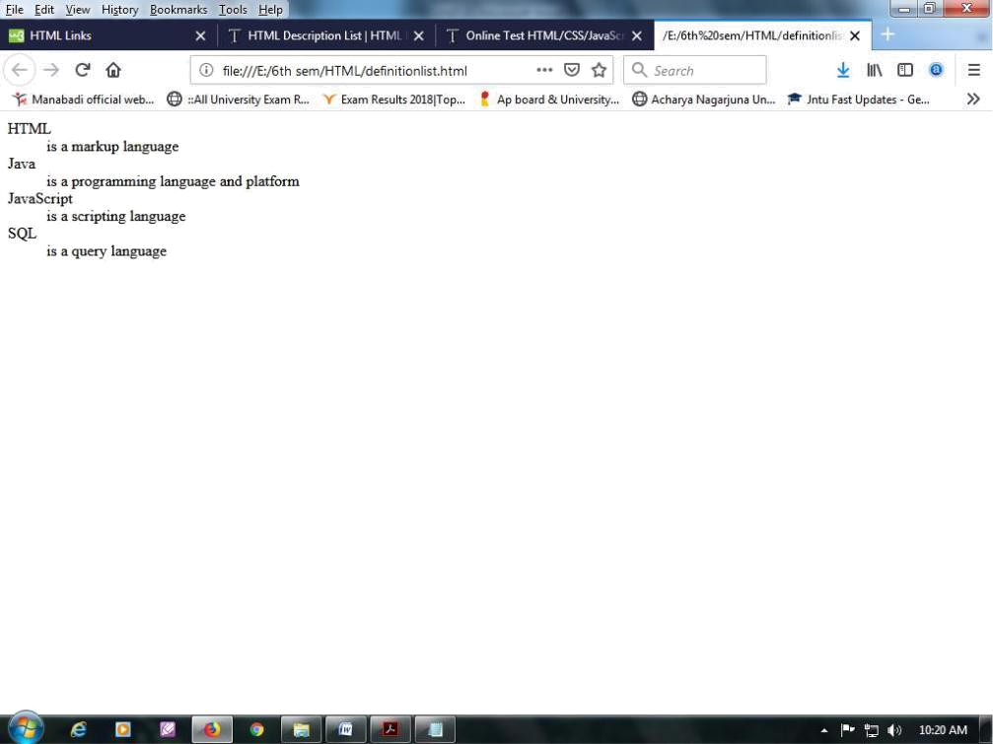

6. Tables

The table is one of the most useful HTML constructs. We will find tables all over the internet. Tables in HTML allow us to organize information in a row and column format.

Tables have two uses: structuring a piece of information and structuring the whole webpage. Many best designed websites on the internet are based around tables. Alternatively you can use structure a webpage using frames.

Basic Table Tags:

<table [align=”center”|”left”|”right”][border=’n][cellpading=”n”][cellspacing=n”][width=”nn%][height=”nn%]> …..

- </table>

Everything between these two tags will be a part of the table. The attributes control the formatting of the table as a whole, but not the items in each cell.

Attribute | Description
Align | Specifies the horizontal alignment of the table. Default value is left.
Border | Specified the width of border around table.
Cellpading | Specifies the spacing between cell border and text. Default value is 1
Cellspacing | Specifies the spacing between cells of the table. Default value is 2
Width | Specifies table width
Height | Specifies table height

₁₅ © Prepared By K.L.RAJU

Table Row <tr>: Each row of the table is created using. It has the following form

<tr [align=”center”|”left”|”right”][valign=”top”|”center”|””bottom]> …. </tr>

Table Data <tad>: used to represent table cell and it data.

<td [align=”center”|”left”|”right”][valign=”top”|”center”|””bottom][nowrap][colspan=”n”][rowspan=”n”]> ….

</td>

Table Heading <th>: Used to create headings for columns in a table.

<th [align=”center”|”left”|”right”][valign=”top”|”center”|””bottom][nowrap][colspan=”n”][rowspan=”n”]> …. </th>

The attributes of <tr>, <td>, <th> are describe below

Attribute | Description
Align | Used to align the contents horizontally
Valign | Used to align the content vertically
Nowrap | If Nowrap is set the content will not be automatically wrapped as the table is formatted for the screen
Colspan | This controls how many columns a text in the table should span
Rowspan | This defines the number of rows the text in the table should span

Example:

<html>
<head>
<title>time table</title>

</head>
<body>

<table align="center" border="1"cellpadding="25" cellspacing="5"> <tr bgcolor="yellow">

<th rowspan=2>Name</th>
<th rowspan=2>Sem</th>
<th colspan=3> Marks</th></tr>

<tr bgcolor="pink">
<td>sub1</td>
<td>sub2</td>

<td>sub3</td></tr>
<tr bgcolor="orange">
<td rowspan=4>cse</td>
<td rowspan=2> 1st</td>

<td>A</td><td>B</td><td>C</td></tr>
<tr><td>100</td><td>100</td><td>100</td></tr>
<tr bgcolor="lightgreen"><td rowspan=2>2nd</td><td>D</td><td>E</td><td>F</td></tr>
<tr bgcolor="lightblue"><td>100</td><td>100</td><td>100</td></tr>
</table><br><br>
</body>
</html>

₁₆ © Prepared By K.L.RAJU

Output:

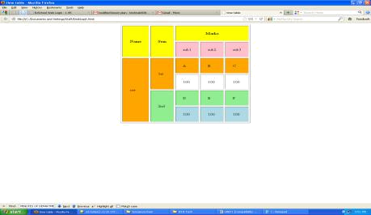

Advanced Tables tags

<caption> …… </caption> : This optional element is used to provide a string which describes the

content of the table. If used it must immediately follow the table element.

Example: <caption>Student Records</caption>

<tbody> …….. </tbody>: It is used to group the body content in a table.

<thead> …….. </thead>: It is used to group the header content in a table.

<tfooter> …….. </footer>: It is used to group the footer content in a table.

<colgroup [span=”n”][width=”n”]> ……. </colgroup>: It specifies a group of one or more columns in a

table for formatting. Each group of columns can be assigned a default width which will apply to all columns. The “span” indicates the number of columns in the group.

<col [span=”n”][width=”n”]> ……. </col>: It is used with <colgroup> element to specify column

properties for each column.

₁₇ – Prepared By K.L.RAJU

Example:

<html>

<head>
<title> A comprensive table </title>

</head>
<body>
<h1>A comprensive table</h1>

<table align="center" width="75%" border="1">
<caption>comprensive table<caption>

<colgroup width="35%" span="2">
</colgroup>

<colgroup span="3">
<colgroup>
<thead>

<tr>
<td clospan="5">The table header</td>

</tr>
</thead>

<body>
<tr>

<td> First </td>
<td> Second </td>
<td> Third </td>

<td> Fourth </td>
<td> Fifth </td>

</tr>
<tr>

<td> First </td>
<td> Second </td>

<td> Third </td>
<td> Fourth </td>
<td> Fifth </td>

</tr>
</body>

<tfooft>
<tr>

<td clospan="5">The table header</td>
</tr>
</tfoot>

</table>
</body>

</html>

₁₈ © Prepared By K.L.RAJU

Output:
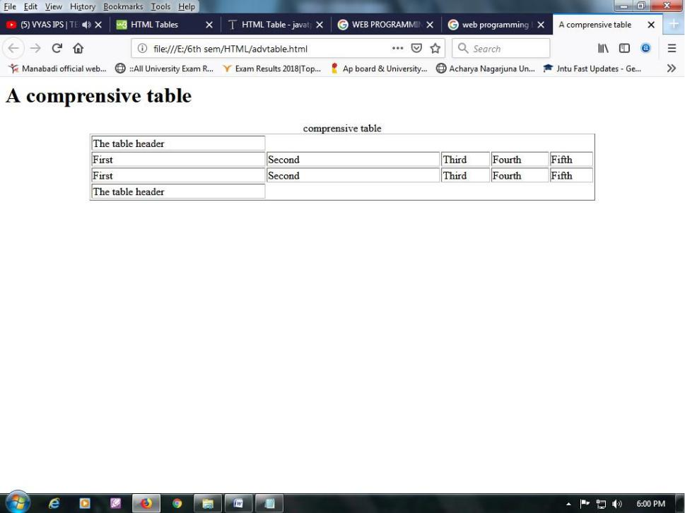

7.Images

While designing a webpage, images play a vital role. It can be used as background of your webpage or as clickable image or as an image mapping. But the only thing is the images loading time. Not all browsers support all of the image formats. Most web developers use .jpeg and .gif formats for image. The <img> tag is used to include images in your HTML page.

<body background=”URL”> ……… </body>: sets background of your page to use the given image.

Example: <body background=”C:\Users\Public\Pictures\Sample Pictures\Penguins.jpg”>…. </body>

<img src=”URL”|”name” height=”n” height=”n” [alt=”string”] [align=”top”|”center”|”bottom”] [usemap=”URL]> ….</img>

Displays an inline image that is an image viewer appears in the body of the text rather than on a page of its own or in a spawned viewer program.

Attribute | Description
Src | Specifies the URL of the Image
Height | Specifies the height of the image
Width | Specifies the width of the image
Align | Specifies the position of the image with respect to the surrounding contents
Usemap | Specifies the client side image map to use.

₁₉ ©– Prepared By K.L.RAJU

Example:

<html>

<head> <! -- This page implements color,image and background --> <title> background with image </title>

</head>

<body bgcolor=”red” background=”C:\Users\Public\Pictures\Sample Pictures\Penguins.jpg "> <h1>Image with Paragraph</h1>

<p>

<img src="C:\Users\Public\Pictures\Sample Pictures\Penguins.jpg" align=right width="50" height="50"> This is an example for<br>
image with text alignment as paragraph <br>

</p><hr>
<h1>Border</h1>

<img src="C:\Users\Public\Pictures\Sample Pictures\Penguins.jpg" align=right width="50" height="50" border="10">
<hr>

<h1>Resize</h1>

<img src="C:\Users\Public\Pictures\Sample Pictures\Penguins.jpg" width="50" height="50" alt="image"> <hr>
<h1>hyper links</h1>

<a href="HTML/links.html">

<img src="C:\Users\Public\Pictures\Sample Pictures\Penguins.jpg" align=right width="50" height="50"> </a>

</body>
</html>

Output;

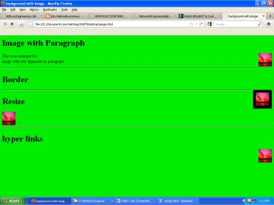

₂₀ – Prepared By K.L.RAJU

Using images as links:

It contains the address of the referenced link as an image i.e. we nested the image with in the anchor tag.

The basic form is

<a href=”address”>

<img scr=”image address” width=”n” height=”n”></img>

</a>

Example:

<a href=”www.manabadi.co.in/results”>

<img scr=”results.jpeg” width=”50” height=”50”></img>

</a>

In the above example, the webpage displays an image, when you click on the image, it will bring you to another page specified in the address filed.

Image mapping

When a hyperlink is created on an image, you can open the webpage specified by the hyperlink. However, HTML also provides the facility to link multiple WebPages to a single image throw a image map.

Image map is a technique that divides the image into multiple sections and allows linking of each section to different web pages. Linked regions and each hot regain hot regions are clicked. Hot regions are specified by the shape attribute of the area tag.

<area shape=”circle”|”rect”|”poly”|”default” href=”URL” coords=”string” alt=”string”>

Creates a clickable area on an image map. The “alt” text in this case is displayed by the browser as indicator for the reader of where the link goes. If you don’t supply an alt your image map is invalid and

may not be displayed. The clickable area can have one of four shapes. Each shape is defined by coordinates which are integer values.

<!DOCTYPE html>
<html>

<body>
<h2>Image Maps</h2>

<p>Click on the computer, the phone, or the cup of coffee to go to a new page and read more about the topic:</p>

<img src="workplace.jpg" alt="Workplace" usemap="#workmap" width="400" height="379"> <map name="workmap">

<area shape="rect" coords="34,44,270,350" alt="Computer" href="computer.htm"> <area shape="rect" coords="290,172,333,250" alt="Phone" href="phone.htm"> <area shape="circle" coords="337,300,44" alt="Cup of coffee" href="coffee.htm">

</map>
</body>

</htm
₂₁ ©– Prepared By K.L.RAJU

More HTML
Including Multimedia objects

People interact with each other through different mediums verbally, visually and something using symbols. The word multimedia simply means being able to communicate in more than one way for better interaction. In other words execution of text, sound, graphics and animation simultaneously is multimedia.

One of the biggest attractions of the web must be the amount of multimedia data that can be presented from within simple text document.

Multimedia is term which can mean radically different things to different to differently people. On the web it is generally used to mean sound and image data. It is probably best used to define any data which is not plain text or simple images.

1. Including objects

HTML4 has an object tag which is used to embed multimedia objects directly into webpage. The general for is

<object classid=”URL” data=”URL”[codebase=”URL”] type=”string” [stand by=”string”] height=”n” width=”n” [title=”string”]> ……..</object>

The attributes of object tag are described below

Attribute | Description
Classid | This identifies the URL of the object.
Codebase | It identifies the directory structure
Type | Used to specify MIME type
Standby | Used to display the alternative test while object itself is being downloaded from the
 | server
Height | Specifies the height of the object
Width | Specifies the width of the object
Title | It specifies the title of the object

<param name=”string” value=”string” type=”string” value type=[“ref”|”object”|”data”]>

Example:
<html>
<head>

<title> An embeded object </title>
</head>

<body>
<h1> an embeded object</h1>

<p> the next paragraph contains an object and some paramaters </p>

<object height="50" width="250" classid="C:\Users\Public\Music\Sample Music\Kalimba.mp3"> <param name="greetee" value="sample music" value type="data">

</object>
</body>

</html>
₂₂ Prepared By K.L.RAJU

2. Applets

Generally an applet represents a Java byte code embedded in a webpage. We can think of an applet as Applet=Java byte code + HTML Tag.

An applet like any application program can do many things for us. It can perform arithmetic operation, displays a graphics, play sounds, create animations and play different games. The general form of <applet> tag is

<applet code=”class file” [name=”string”] width=”n” height=”n” [codebase=URL”]> …… </applet>

Example: The following program shows how to include an applet in your webpage.

Java Program

Import java.awt.*;

Import java.applet.*;
public class AppletDemo extends Applets
{

String s=”Hello Java”;

Public void run(Graphics g)
{

g.drawString(5,10,10);
}
}

HTML program

<html>

<head>
<title> Applet</applet>

</head>
<body>

<applet code=”AppletDemo.class” height=”500” width=”500”> </applet>
</body>

</html>

₂₃ © Prepared By K.L.RAJU

Frames

In HTML it is possible to split the webpage into different sizes. To do this HTML provides three tags<frameset>, <frame>, <iframe>.

Frame based sites display more than one page at the same time; they can be complex to setup. Once the layout is established, frame based sites can require less maintenance than alternative approaches.

A frame based page is actually made from a set of documents, each displayed in its own frame. Each frame sub document can have its own scroll bars and can be loaded, reloaded and printed as if it were occupying the whole screen.

(A) Frameset

<frameset [cols=”n% n%”] [row=”n% n%”]> …… </frameset>

A group of frames in a single browser window is called frameset. This tag determines how the screen will be divided between the various frames that you are using. You can have as many frames either vertically or horizontally as you want.

(B) Frame

<frame [name=frame name”] src=”filename” [scrolling=”yes” |” auto|”no”] [frame border=”0”|”1”]>

- The src attribute should point to image or a document which can be displayed within the frame.

- The name attribute specifies the name of the frame

- The scrolling attribute specifies three values: yes, No, auto
Example:

<html>
<head>

<title>Frame Demo</title>
</head>

<frameset rows="25%,50%">
<frame name="A" src="./company.html">

<frame name="B" src="./oreders.html" scrolling="no"> </frameset>
</html>

- Iframe: The <iframe> tag specifies an inline frame.

An inline frame is used to embed another document within the current HTML document. <!DOCTYPE html>

<html>
<body>
<iframe src="https://www.w3schools.com">

<p>Your browser does not support iframes.</p>
</iframe>

</body>
</html>

₂₄ – Prepared By K.L.RAJU

Forms

Forms are the best way of adding interactivity of element in a web page. They are usually used to let the user to send information back to the server but can also be used to simplify navigation on complex web sites. The tags that use to implement forms are as follows.

<forms action=”URL” method = “post” | “get”>…….</form>

When get is used, the data is included as part of the URL. The post method encodes the data within the body of the message. Post can be used to send large amount of data, and it is more secure than get. The tags used inside the form tag are:

<input type = “text” | “password” | “checkbox” | “radio” | “submit” name=”string” value=”string” size=”n”>

In the above tag, the attribute type is used to implement text, password, checkbox, radio and submit button.

Text: It is used to input the characters of the size n and if the value is given than it is used as a default value.
It uses single line of text. Each component can be given a separate name using the name attribute.

Password: It works exactly as text, but the content is not displayed to the screen, instead an * is used.

Radio: This creates a radio button. They are always grouped together with a same name but different values.

Checkbox: It provides a simple checkbox, where all the values can be selected unlike radio button.

Submit: This creates a button which displays the value attribute as its text. It is used to send the data to the server.

<select name=”string”>…..</select>

This tag helps to have a list of item from which a user can choose. The name of the particular select tag and the name of the chosen option are returned.

<option value=”string” selected>……</option>

The select statement will have several options from which the user can choose. The values will be displayed as the user moves through the list and the chosen one returned to the server.

<textarea name=”string” rows=”n” cols=”n”>…….</textarea>

This creates a free format of plain text into which the user can enter anything they like. The area will be sized at rows by cols but supports automatic scrolling.

₂₅ © – Prepared By K.L.RAJU

Example

<html>

<head>
<title>form</title>

</head>
<body>

<p align="left">Name:<input type="text" maxlength=30 size=15>

<p align="left">Password:<input type="password" maxlenght=10 size=15> <p align="left">Qualification: <br>

<input type="checkbox" name="q" value="be">B.E <input type="checkbox" name="q" value="me">M.E <p align="left">Gender:<br>

<input type="radio" name="g" value="m">Male <input type="radio" name="g" value="f">Female <p align="left">course:

<select name="course" size=1>
<option value=cse >CSE</option>
<option value=it>CSIT</option>

</select>
<p align="left">Address:<br>

<textarea name="addr" rows=4 cols=5 scrolling=yes></textarea>
<p align="center"><input type="submit" name="s" value="Accept">

<p align="center"><input type="reset" name="c" value="Ignore">
</body>
</html>

Output:

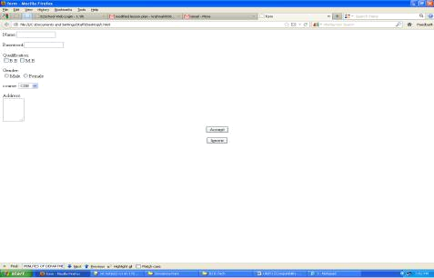

₂₆ © Prepared By K.L.RAJU

HTML document head detail

The head is very important part of any HTML page. It contain lost of control information that is need by browsers and servers. You need to use some of the <head> tags that are discussed here as a part of your webpage head section.

(a) Document Type declaration (DTD):

Document Type declaration (DTD) is very first thing in your HTML document before the <html> tag. The <!Doctype> declaration is not an<html> tag it can instruct to the web browser about what type of HTML you are using.

<!DOCTYPE HTML PUBLIC "-//W3C//DTD HTML 4.01 Transitional//EN" "http://www.w3.org/TR/html4/loose.dtd">

If a version of HTML other than 4.0 is used the version number in the Doctype declaration should be changed. Languages other than English are specified by changing the ‘en’ as appropriate. The w3c has created the following DTD’s for HTML

- Loose 2. Strict 3.Traditional 4.Frameset b) Control information

The head of the document contains control information used by servers and web browsers. It contains the title of the document which will be displayed at the top of the Brower and optionally a list of keywords, a description of the document, any file to be linked into the document, and information about how the document was prepared.

<title> …….. </title>

To include title of the web page, use this tag.

<base href=”URL”>

This tag is used to enforce relative links. Linking between pages and documents will be explained in detail in the body section. This tag is optional.

<link rel=”type” href=”URI” type=”string” media=”string”>

The link tag is used to allow other documents to be linked to, or included in, the current document.
This tag has not commonly been used but it is important and useful when using style sheets.

<meta name|type-equiv=”string” content=”string”>

Any information which describes the whole document should be included using one of these two alternatives
- you should use the “name” attribute for meta data which you are defining

- The “http-equiv” attribute is used to define metal data which is intended to be part of an http response message

₂₇– Prepared By K.L.RAJU

UNIT-I Questions
Note: Two Questions will be given in public exam.

Basics of HTML

- Explain the features of the HTML program.

- Discuss about structure of HTML program
- Explain about formatting tags with examples.
- Explain about hyperlinks in HTML with example.

- Discuss about image maps with an example program.
- Discuss about different types of lists in detail.

- Discuss about tables in HTML.

More HTML

- Discuss about forms in detail
- Differentiate between HTML and XHTML with illustrations.
- Write about frames in HTML.

- What is an Applet? Design a web page to display an Aapplet.
- Explain about the tags to include multimedia objects in web pages.

UNIT – II
Cascading Style Sheets

Introduction, using Styles, simple examples, your own styles, properties and values in styles, style sheet, formatting blocks of information, layers

……………………………………………………………………………………………………………………………

1. Introduction

What is CSS?

- CSS stands for Cascading Style Sheets

- CSS describes how HTML elements are to be displayed on screen, paper, or in other media

- CSS saves a lot of work. It can control the layout of multiple web pages all at once

- External style sheets are stored in CSS files

Why Use CSS?

CSS is used to define styles for your web pages, including the design, layout and variations in display for different devices and screen sizes.

CSS Syntax

A CSS rule-set consists of a selector and a declaration block:

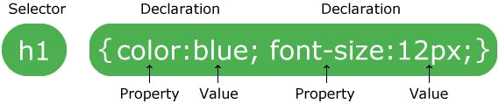

  - The selector points to the HTML element you want to style.

  - The declaration block contains one or more declarations separated by semicolons.

  - Each declaration includes a CSS property name and a value, separated by a colon.

  - A CSS declaration always ends with a semicolon, and declaration blocks are surrounded by curly braces.

- Using Styles:: Simple Example

In the following example all <p> elements will be center-aligned, with a red text color:

<!DOCTYPE html>
<html>

<head>
<style>
p {
color: red;
text-align: center;

}
₁

</style>
</head>
<body>

<p>Hello World!</p>
<p>These paragraphs are styled with CSS.</p>

</body>
</html>

Advantages and Disadvantages of CSS

CSS stands for Cascading Style Sheet. It allows you to specify how documents are presented to users by using various style properties for a given HTML element. CSS properties are the key to altering the styling of HTML elements in your web documents.

Some Advantages of using CSS

Separation of Style and Structure

It allows separating content of an html document from the layout & style of that document.

Search engine friendly

It helps get your pages found in a search engine. Since your CSS website contains less code and has a simpler structure which allows search engine spiders to pass from your code faster means your web pages can be indexed faster

Save time

It flexibility to set the properties of an component. You can write CSS code and then the same code can be applied to the HTML components groups, and also can be reused in different HTML pages.

Easy to Maintain

It gives an easy mode to update document formatting and manage consistency across various documents. By doing one change to the website's CSS file, all the web pages’ elements will be updated automatically.

Pages load faster

it empowers multiple pages to share formatting, and reduce complexity and redundancy in the structural content. It significantly reduces the file transfer size, which helps to lode page faster.

Superior styles to HTML

It has more extensive presentation capabilities than HTML, so you can give far superior look to your HTML pages in contrast with the HTML elements and attributes.

Multiple Device Compatibility

₂

It allows the HTML document to be improved for more than kind of device. Using it the same HTML document can be presented in various review styles for various rendering devices.

Provide Platform independence

It offer consistent platform independence and also support latest browsers as well.

Global web standards

It’s a better to start using CSS in all the HTML pages to make them compatible for future browsers.

There are various CSS properties which help to enhance your web experience.

While CSS has several benefits, some designers are quick to list the following cons:

Speed: Downloading an HTML page will always take longer if CSS is embedded within it. However, with ever-increasing Internet speeds, this is less of a problem than you might imagine.

Weirdness: While CSS is easy to use and understand, its syntax is very different from HTML and not terribly user-friendly. This forces developers to take time to learn two different types of code and then understand how they interact with each other.

Complications: CSS can get messy and complicate the creation of websites with third-party software, such as Dreamweaver or Microsoft FrontPage.

Various Types of CSS

There are the following three types of CSS:

- Inline CSS.
- Internal / Embedded CSS.
- External CSS.

Inline CSS

For Inline CSS every style content is in HTML elements. It is used for a limited section. Whenever our requirements are very small we can use inline CSS.

It will affect only single elements. In HTML we require that various HTML tag's views are different so then we use inline Cascading Style Sheets. There are disadvantage of inline Cascading Style Sheets. It must be specified on every HTML tag. There is very much time consumed by that and it is not the best practice for a good programmer and the code will be quite large and very complex.

Inline CSS examples are given below:

<!DOCTYPE html>
<html>
<body>

<h1 style="color:blue;">This is a Blue Heading</h1>
₃

</body>
</html>

Internal CSS

In internal CSS the style of CSS is specified in the <head> section. This is internal CSS, it affects all the elements in the body section. Internal CSS is used in the condition when we want a style to be used in the complete HTML body. For that we can use style in the head tag.

This style performs an action in the entire HTML body.

<!DOCTYPE html>
<html>
<head>
<style>
body {background-color: powderblue;}
h1{color: blue;}

p{color: red;}
</style>
</head>
<body>
<h1>This is a heading</h1>
<p>This is a paragraph.</p>
</body>

</html>

External CSS

In External CSS we create a .css file and use it in our HTML page as per our requirements. Generally external Cascading Style Sheets are used whenever we have many of HTML attributes and we can use them as required; there is no need to rewrite the CSS style again and again in a complete body of HTML that inherits the property of the CSS file.

Example:

styles.css

body {
background-color: powderblue;
}
h1 {

color: blue;

}
p {
color: red;

HTML Program

<!DOCTYPE html>
₄

<html>
<head>
<link rel="stylesheet" href="styles.css">
</head>
<body>

<h1>This is a heading</h1>
<p>This is a paragraph.</p>
</body>

</html>

4. Defining your own styles

Styles are defined by simple rules. A style can contain as many rules as you want and with processing HTML.

1. Cascading styles:

Conventionally styles are cascaded (overridden). This means that you do not have to use just a single set of rules inside a document, you can import as many styles as you like. The only difficulty with importing multiple style sheets is that they cascade. This means that the first is overridden by second, the second by third and so on.

2. Style Rule:

A style rule has two parts: The selector and a set of declarations. The selector is used to create a link between the rule and the HTML tag.
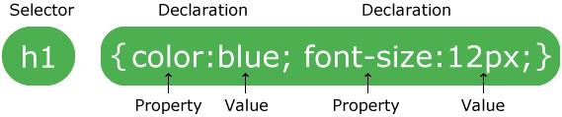

The declaration part has two parts: a property and a value. Selectors can be placed into classes so that a tag can be formatted in variety of ways. Declarations must be separated using colons and terminated using semicolon.

3. Classes

A class is defined a set of styles which can be applied as user choice. Choices can be applied to a single type of element or may be anonymous and hence applicable to any element.

If you want to apply a style to a particular element use the following syntax

Selector.classname{property: value; property: value}

<selector class=”classname”>

<!DOCTYPE html>
<html>
<head>
<style>
p.center {

₅

text-align: center;
color: red;
}
</style>
</head>
<body>

<h1 class="center">This heading will not be affected</h1>
<p class="center">This paragraph will be red and center-aligned.</p>

</body>
</html>

4. Anonymous classes

Sometimes you want to apply a piece of formatting too many different elements within a page but not necessarily to the entire page. Instead of defining styles to individual elements we are creating a style class that can be applicable any number of tags in your HTML document. Such classes are called anonymous classes. It has the following syntax

.classname
{
Property: value;
Property: value;
}

<selector1 class=”classname”> ………. <selector1>
<selector2 class=”classname”> ………. <selector2>

Example:

<!DOCTYPE html>
<html>
<head>
<style>
.center {
text-align: center;

color: red;
}
</style>
</head>
<body>

<h1 class="center">Red and center-aligned heading</h1> <p class="center">Red and center-aligned paragraph.</p>

</body>
</html>

₆

Including style sheets

We can include style sheets in our HTML page in two way (i) by linking (ii) by importing

(i) By linking

We can link our .css file in the head section of a HTML page using the following syntax

<link rel=”style sheet” href=”URL” type=”text/css” media=”screen”>

The href is hyperlink to your style sheet
Rel tells to the browser what type of link you’re using

Type tells to the browser what type of document you’re including, the ‘type’ statement gives the relevant MIME type.

Finally it is useful, although not compulsory, to tell the browser how the document will be used. HTML Specifies a Varity of ways of using a document a document, including screen viewing, printing and as a presentations. Use the ‘media’ attribute to describe the type of use.

<!DOCTYPE html>
<html>
<head>
<link rel="stylesheet" type="text/css" href="mystyle.css" media=”screen”>
<style>
h1 {
color: orange;

}
</style>
</head>
<body>

<h1>This is a heading</h1>

<p>The style of this document is a combination of an external stylesheet, and internal style</p>

</body>
</html>

(ii) By importing

[<style type=”text/css”>]
<!--@import url(url); --> </style>

These lines are both needed if you intended to use more than one style sheet. The first sheet is included as if it were the only one; any further style sheets have to be imported.

Example:

<link rel="stylesheet" type="text/css" href="mystyle.css" media=”screen”> <style type=”text/css”>

<!--@import url(“http://www.smiggins.co./style.css); --> </style>

₇

4. Properties and Values

There are number of style properties, including properties that control lists and positing floating elements like images.

(i) Font properties:

font-family: family name;
Fonts are identified by giving the name of a specific font.

font-style: normal | italic | oblique;

This property provides the style to the font.

font-weight: normal | bold | bolder | lighter;

The font-weight property selects the weight or darkness of the font. Values of the property range from 100 to 900 in increments of 100.

font-size: small | medium | large | smaller | larger;

This property is used to set the relative or physical size of the font used.

Example:

<html>
<head>
<title> Font properties </title>
<style type=”text/css”>
h1{ font-family:arial;

font-style: italic;
}
P{
Font-weight: bold
Font-size:100px;
}
</style>

</head>
<body>
<h1> demo from css properties </h1>

<p> this paragraph represents font size and font weight</p> </body>
</html>

(ii)Backgrounds and color properties

Color:<value>
Background-color:<value> | transparent
Background-image: URL | none

- The color of any attribute can be changed. Value should be given as hexadecimal values.
₈

- Backgrounds for the whole page or individual element can have their color set from the style sheet. Elements can also have transparent backgrounds.
- Instead of a color an image can be used, identified by its URL.

Example:

<html>
<head>
<title> Font properties </title>

<style type=”text/css”>
h1{
background-color: white;
color: black;

}
P{
background-color: black;
color: white;
}
</style>

</head>

<body>
<h1> demo from css background and color properties </h1>
<p> this paragraph represents font size and font weight</p>
</body>
</html>

(iii) Text Properties

Text properties are used to effect the presentation, spacing and layout of text. The basic properties includes such as decoration, indentation, word spacing, letter spacing, spacing between lines, horizontal and vertical text alignment.

text-decoration: none | underline | overline| line-through| blink;
text-transformation: none | uppercase | lowercase| capitalize;
text-align: left | right | center | justify;
text-indentation: length | percentage;
line-height : length | percentage;
letter-spacing: length | percentage;

word-spacing: length | percentage;

Example

<html>
<head>

<title> text properties </title>
<style type=”text / css”>
a{

text-decoration: overline;
text-transformation: uppercase;
text-align: left;
₉

text-indentation: 12px;
}

</style>
</head>
<body>

<a href=”D:/CSS Demo/Mycss.html> This hypertext has text properties </a> </body>
</html>

(IV) Box Properties

All HTML elements can be considered as boxes. In CSS, the term "box model" is used when talking about design and layout.

The CSS box model is essentially a box that wraps around every HTML element. It consists of: margins, borders, padding, and the actual content. The image below illustrates the box model:

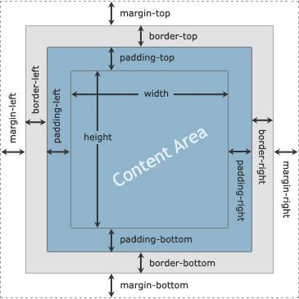

Margin: length | percentage | auto {1,4}
Border-width: thin | thick | medium | length {1,4}
Padding: length | percentage {1,4}

Padding - Clears an area around the content. The padding is transparent

Border - A border that goes around the padding and content
Margin - Clears an area outside the border. The margin is transparent

Border-color: value {1,4}
Border-style: none | dotted | solid | double | groove
Ridge { 1,4}

This sets the color of the border around the element. Up to four different colors can be specified. They are applied to the borders in the same orders as margins. Each edge of the border can have a different style.

Width: length | percentage | auto
Height: length | auto

₁₀

Any block level element can be given a specific width and height.

Example:

<!DOCTYPE html>
<html>

<head>
<style>
div {

width: 320px;
padding: 10px;
border: 5px solid gray;
margin: 0;

}
</style>
</head>
<body>

<h2>Calculate the total width:</h2>

<img src="klematis4_big.jpg" width="350" height="263" alt="Klematis">
<div>The picture above is 350px wide. The total width of this element is also 350px.</div>

</body>
</html>

- Units and URLs

- lengths

These can be either absolute or relative. A relative length can be either positive or negative, which is indicated by preceding the value with an optional + or –

Relative units that can be used are: em, ex, px
Allowable absolute units are: in, cm, mm, pt, pc

- URLs can be used in style sheets just as they can in HTML documents. The format of the URL reference is url(location)

₁₁

5. Formatting Blocks of Information

A webpage may consist of more than one block. We can format all the blocks with single style or separate style for each and every block. This can be achieved in three ways

- Using style class
- Using <div> tag
- Using <span> tag

1. Using class

A class is defined a set of styles which can be applied as user choice. Choices can be applied to a single type of element or may be anonymous and hence applicable to any element.

If you want to apply a style to a particular element use the following syntax

Selector.classname{property: value; property: value}

<selector class=”classname”>

<!DOCTYPE html>
<html>
<head>
<style>
p.center {

text-align: center;
color: red;
}
</style>
</head>

<body>

<h1 class="center">This heading will not be affected</h1>
<p class="center">This paragraph will be red and center-aligned.</p>

</body>
</html>

Anonymous classes

Sometimes you want to apply a piece of formatting too many different elements within a page but not
necessarily to the entire page. Instead of defining styles to individual elements we are creating a style class that

can be applicable any number of tags in your HTML document. Such classes are called anonymous classes. It has

the following syntax
.classname
{
Property: value;
Property: value;
}

<selector1 class=”classname”> ………. <selector1>
₁₂

<selector2 class=”classname”> ………. <selector2>
Example:

<!DOCTYPE html>
<html>
<head>

<style>
.center {
text-align: center;

color: red;
}
</style>
</head>

<body>

<h1 class="center">Red and center-aligned heading</h1> <p class="center">Red and center-aligned paragraph.</p>

</body>

</html>

2. Using <div> tag

An element in an HTML document is either a block element or an inline element. A block would be something like a paragraph, while an inline might be something like text, a figure or an individual character i.e., part of block. Each of these can be manipulated separately, rather than applying the formatting to the element itself, a <div> ….. </div> pair of tags are wrapped around the elements. Any formatting that needs adding is

placed inside the <div> tag. The <div> tag has the following syntax:

<div class=”any element”>
<p> ……. </p>
<p> …….. </p>

<hr>
</div>

Example:

<html>

<head>
<title> div tag css demo </title>
<head>
<style type=”text / css”>
.fred

{

color: white;
background-color: 009900;
margin: 2px;
font-size: 25px;
}
</style>
</head>
₁₃

<body>
<div class “fred”>
<h3> this is heading inside division </h3>

<p> The div tag is known as Division tag. The Div tag is used in HTML to make divisions of content in the web page like (text, images, header, footer, navigation bar etc).</p> </div>

</body>
</html>

3. Using <span> tag:

The <span> tag has very similar properties to the <div> tag. If you want to group text without using elements use a <span> tag. It has the following syntax

<span [id=”…..”][class=”…..” | style=”…..”]>……. </span>

What is the difference between <span> and <div>?

Span as an in-line element and a div as a block level element.

Span:

The span element basically occupies only the amount of space required by the element , it will not take the whole space/width of the web page .

Second thing is span doesn't breaks the line , i.e. all the spans will be shown in single line in a web page as shown in the screenshot below.

Div:

The div element occupies all the width available to it on the web page and every time a new div element is made it breaks the line and starts in a new line.

<!DOCTYPE html>
<html>

<head>
<title>HTML span Tag</title>

</head>

<body>

<p>This is a paragraph <span style = "color:#FF0000;"> This is a paragraph</span>This is a paragraph</p>

<p><span style = "color:#8866ff;">
This is another paragraph</span></p>
</body>

</html>

₁₄

6. Layers in HTML

The page layout that a browser creates results from layering text and images on the top of each other. This lets web designers use images as the backgrounds of their pages and then place further images and text over them. By extending the idea slightly we can place text items and images on top of each other in multiple layers.

Netscape has extended the HTML standard by adding the layer tag. The layer tag is browser specific and it use leads to confusion with the more general idea of layers. The following are the properties and values of layers.

Z-index: n

The browser maintains a stack of layers of content.

Position: absolute | relative

The placement of the layer may be absolute or relative. The default is absolute.
Left: n, Top: n

The location of the division in pixels. We can specify the position of their top-left corner.

Width: n, Height: m

The size of division in pixels defaults to the document of space needed to display the content
of the division.

Example:

<!DOCTYPE html>

<html>

<head>
<title>HTML layer Tag</title>
</head>

<body>

<div style="z-index:2;
left:50px;
top:250px;
position:absolute;

color:red;

backround-color:white;
font-size:36pt;
border:thin-groove;">
<p> This is the higher layer </p>
</div>

₁₅

<div style="z-index:1;
left:100px;
top:255px;
position:absolute;
color:magenta;
backround-color:green;

font-size:46pt;
border:thin-groove;">
<p> some mor text</p>

</div>

<div style="z-index:4;
left:10px;

top:40px; width:150px;
position:absolute;
color:black;
backround-color:yellow;
font-size:18pt;">

<p> some mor text plcaed in a box that doesn't go right across the screen</p> </div>

<div style="
left:500px;
top:300px; width:25px;
position:absolute;
color:blue;
backround-color:#aeae00;

font-size:16pt;
font-style:italic;z-index:2;
">
<p> And in the bottom right corner.....</p>
</div>
</body>

</html>
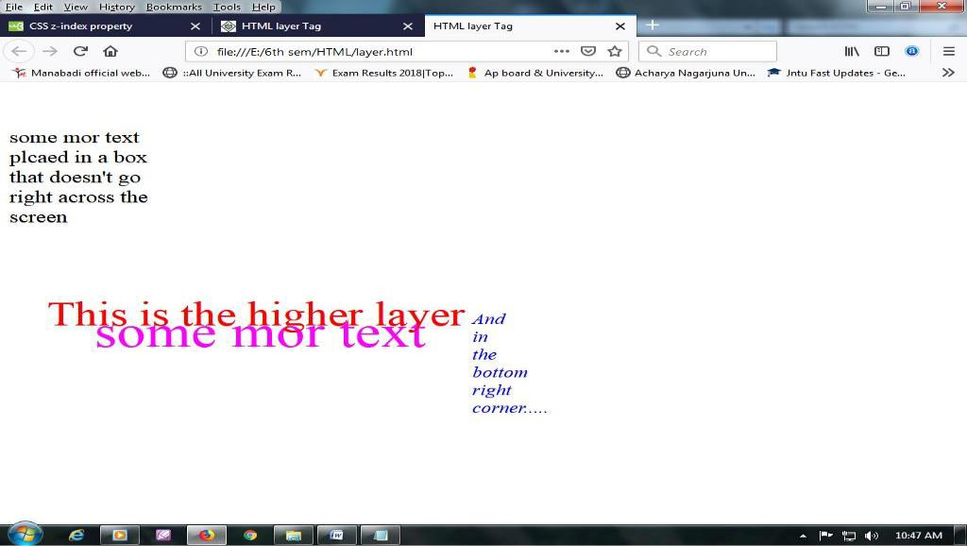

₁₆

UNIT-II
Questions
How to define our own style sheets? Explain.
Explain about property and values in HTML.
Explain about Layers.

What is the purpose of cascading style sheets? Explain the types of cascading style sheets. (OR)

Describe different ways that styles can be added to a page. (OR)
Explain different ways of linking style sheets.
Write about style rule and classes.

Discuss about <dvi> and <span> tags.
Explain different ways to inherit CSS.
Explain styles Vs Formatting.

UNIT – III
Introduction to JavaScript

What is DHTML, JavaScript, basics, variables, string manipulations, mathematical functions, statements, operators, arrays, functions.

Objects in JavaScript: Data and objects in JavaScript, regular expressions, exception handling
………………………………………………………………………………………………………………………….

1.What is DHTML?

Dynamic HTML, or DHTML, is an umbrella term for a collection of technologies used together to create interactive and animated websites by using a combination of a static markup language (such as HTML), a client-side scripting language (such as JavaScript), a presentation definition language (such as CSS), and the Document Object Model (DOM). The application of DHTML was introduced by Microsoft with the release of Internet Explorer 4 in 1997.

Differences between HTML and DHTML:

- HTML is a mark-up language, while DHTML is a collection of technology.

- DHTML creates dynamic web pages, whereas HTML creates static web pages.

- DHTML allows including small animations and dynamic menus in Web pages.

- DHML used events, methods, properties to insulate dynamism in HTML Pages.

- DHML is basically using JavaScript and style sheets in an HTML page.

- HTML sites will be slow upon client-side technologies, while DHTML sites will be fast enough upon client-side technologies.

- HTML creates a plain page without any styles and Scripts called as HTML. Whereas, DHTML creates a page with HTML, CSS, DOM and Scripts called as DHTML.

- HTML cannot have any server side code but DHTML may contain server side code.

- In HTML, there is no need for database connectivity, but DHTML may require connecting to a database as it interacts with user.

- HTML files are stored with .htm or .html extension, while DHTML files are stored with .dhtm extension.

  - HTML does not require any processing from browser, while DHTML requires processing from browser which changes its look and feel.

- JavaScript

A JavaScript is a scripting language used at the client side design along with HTML,CSS, and XML. The main use of JavaScript is to validate the data present in a web application. One can also control the web application using JavaScript.

Example: For example, when your login into a Facebook page account you need to provide correct user name and password. If anything went wrong it display an error message. That means someone at the background validating the username and password. This type of validation can be done using JavaScript.

Benefits / Advantages of JavaScript

- JavaScript has a number of big benefits to anyone who wants to make their website dynamic.
- It is widely supported in web browsers
- It gives easy access to the document object and can manipulate most of them.
- JavaScript can give interesting animations without the long download times associated with many multimedia data types.

- Web servers don’t need a special plugin to your scripts.
- JavaScript is relatively easy.

Problems with Java Script

- Most scripts relay upon manipulating the elements of the DOM. Support for standard set of objects currently does not exist and access to objects differs from browser to browser.

- If your script does not work then your page is useless.
- Because of the problem of broken scripts many web pages suffers disable JavaScript support in their browsers.

- Scripts can run slowly and complex scripts can take a long time to startup.

Note
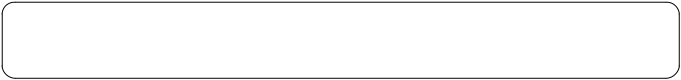

Plugin: plugin is small application which handle specific data type and which may either run as standard alone application or embedded within the browser.

3. JavaScript Basic

a) Including JavaScript in your HTML Page.

We can include JavaScript in two areas of a HTML document. The script is included in the webpage and run by the browser usually as soon as the page loaded. The browser is able to debug the script and can display errors.

In HTML, JavaScript code must be inserted between <script> and </script> tags.
i) ) Including JavaScript in Header section.
The JavaScript which is included in the header section of the webpage will be run as soon as the web
browser is loaded and it is sometimes useful to execute a function that result when the browser is loaded.
Example:
<!DOCTYPE html>
<html>
<head>
<script>
function myFunction() {
document.getElementById("demo").innerHTML = "Paragraph changed.";
}
</script>
</head>
<body>

<h2>JavaScript in Head</h2>

<p id="demo">A Paragraph.</p>

<button type="button" onclick="myFunction()">Try it</button>

</body>
</html>

ii) Including JavaScript in body section.
One can include the JavaScript in the body section when they want to execute some of the functions like
validating the text, event handling etc. The code inside the body react depending upon the conditions or
code present in the HTML document.
<!DOCTYPE html>
<html>
<body>
<h2>JavaScript in Body</h2>
<p id="demo">A Paragraph.</p>

<button type="button" onclick="myFunction()">Try it</button> <script>

function myFunction() {
document.getElementById("demo").innerHTML = "Paragraph changed.";
}
</script>

</body>
</html>

iii) Using external JavaScript file.

If we use a lot of scripts or our scripts are complex then including the code inside the webpage will make your source file difficult to read and debug. We can put JavaScript code in a separate file and include the code in the head of the webpage. JavaScript programs are stored in files with the .js extension.

myScript.js

function myFunction() {

document.getElementById("demo").innerHTML = "Paragraph changed."; }

To use an external script, put the name of the script file in the src (source) attribute of a <script> tag:

<script src="myScript.js"></script>

Example:

<!DOCTYPE html>
<html>
<body>
<h2>External JavaScript</h2>
<p id="demo">A Paragraph.</p>

<button type="button" onclick="myFunction()">Try it</button> <p>(myFunction is stored in an external file called "myScript.js")</p> <script src="myScript.js"></script> </body>

</html>

b) Input and output statements in JavaScript

Input: In JavaScript the input is get by using prompt box. This function frames a window object and its general form is

Syntax: Window.prompt (“ “, variable name);
Example: Window.prompt (“enter your name”, name);

Output: In JavaScript t he data can be displayed on the web page by using two functions: write() and writeln(). The general form is

Syntax: window. write(“message”, variable name);
window. writeln(“message”, variable name);

c) Data types in JavaScript:

Like all other languages JavaScript also supports data types. A data type represents the type of the data and the operations that can be performed on that data. JavaScript supports four types of data types.

- Numerical data types: These are the basic numbers it can include all the integers, fractions and expression data.

Example: Numeric a=10;

- String data type: These are collection of characters or a single character in the double quotes. The string data type can also store numbers represented in the form of string using double quotes.

Example: string s=”c”;
String s1=”1234”;

- Boolean data type: Boolean variables hold the values “ true” and “false”. These are used a lot in programming to hold results of conditional text.

- Null data types: This is used when you don’t know something. A Null value means one that has been decided.

d) Alternatives to JavaScript:

There are so many alternative solutions to the problem of making websites interactive and dynamic. Some of these rely upon complex multimedia data, while others are script based. Some of the scripting solutions which might be consider as competitors to JavaScript are listed below.

Perl: A complex language that is commonly used for server side CGI scripting. Perl is available for client side work through a subset called PerlScript which can also be used when writing active server pages.

VBScript: widely used but unfortunately platform specific. This language is only available under the Microsoft windows operating system.

Python: A little known languages that is making inroads into the CGI writing area. A web browser has been written in Python which can run Python applets.

TCL: This has been a popular choice for systems programming. The language itself has been widely criticised by proponents of other scripting languages but it is clearly effective in its own niche.

Java: This is a scripting language but it is used for many of the same things as JavaScript. It’s very good at menus and data validation on the client but can be very slow.

5. String Manipulation / String Functions / String Object

A sting is collection of characters. The sting object is used to manipulate a stored piece of text, String objects are created as,

Var t1= new String (“hello”);

Or

Var t1= “hello”

JavaScript has functions which perform different operations on stings such as string comparison, searching a string in another string, converting from one case to another one.

1. String Length: The length property returns the length of string

Example: Var s1=”hello”;
S1.length;

The above example returns the length of string as 5.

2. Finding a String in a String

The indexOf() method returns the index of (the position of) the first occurrence of a specified text in a string.

Example: |  |  | s1
 | h | e |  | l | l | o
 | 0 | 1 |  | 2 | 3 | 4
Var s1=”hello”;
indexOf(l);
In the above example, the indexOf() returns index position 2.

The lastIndexOf() method returns the index of the last occurrence of a specified text in a string.

Example: Var s1=”hello”;
lastIndexOf(l);
In the above example, lastIndexOf() returns index position 3.

  - Both indexOf(), and lastIndexOf() return -1 if the text is not found.

- Extracting String Parts

There are 3 methods for extracting a part of a string:

slice(start, end)

substring(start, end)
substr(start, length)

The slice() Method

- slice() extracts a part of a string and returns the extracted part in a new string.
- The method takes 2 parameters: the start position, and the end position (end not included).

This example slices out a portion of a string from position 7 to position 12 (13-1):

Example:

var str = "Apple, Banana, Kiwi";
var res = str.slice(7, 13);

The result of res will be: Banana

The substring() Method

- substring() is similar to slice().
- The difference is that substring() cannot accept negative indexes.

Example:

var str = "Apple, Banana, Kiwi";
var res = str.slice(7, 13);

The result of res will be: Banana

The substr() Method
- substr() is similar to slice().
- The difference is that the second parameter specifies the length of the extracted part.

Example:
var str = "Apple, Banana, Kiwi";
var res = str.slice(7, 6);

The result of res will be: Banana

4. Replacing String Content

The replace() method replaces a specified value with another value in a string.

Example:
str = "Please visit Microsoft!";
var n = str.replace("Microsoft", "W3Schools");

8 © www.anuupdates.org Prepared by Dodda. Venkata Reddy _{M.Tech}
The value of ‘n’ will be ‘Please visit W3Schools’

  - The replace() method does not change the string it is called on. It returns a new string.
  - By default, the replace() method replaces only the first match.
  - By default, the replace() method is case sensitive.

- Converting to Upper and Lower Case

A string is converted to upper case with toUpperCase().

Example:

var text1 = "Hello World!"; // String
var text2 = text1.toUpperCase(); // text2 is text1 converted to upper

A string is converted to lower case with toLowerCase()

Example:

var text1 = "Hello World!"; // String

var text2 = text1.toLowerCase(); // text2 is text1 converted to lower 6. The concat() Method

concat() joins two or more strings:
Example:
var text1 = "Hello";
var text2 = "World";
var text3 = text1.concat(" ", text2);

7. String.trim()

The trim() method removes whitespace from both sides of a string:
Example:
var str = " Hello World! ";
alert(str.trim());

8. Extracting String Characters

The charAt() Method
The charAt() method returns the character at a specified index (position) in a string:
Example:
var str = "HELLO WORLD";
str.charAt(0); // returns H

Note:
All string methods return a new string. They don't modify the original string.

9 © www.anuupdates.org Prepared by Dodda. Venkata Reddy _{M.Tech}
Formally said: Strings are immutable: Strings cannot be changed, only replaced.

6. Mathematical Functions / Math Object
Mathematical functions and values are part of a built in JavaScript object called Math. All functions and attributes used in complex mathematics must be accessed via this object.

  - NaN: This is value which represents something which is not a number. If any mathematical calculation returns other than number format then the JavaScript outputs those results as NaN.

  - abs(value): Returns the absolute value the number passed into it.

  - acos (value), asin(value), atan(value): These functions return the arccosine, arcsine and arctangent respectively of the value passed into them. All return values are in radians.

  - atan2(value): Returns the arctangent, in radios, of the quotient of the values passed into it.

  - ceil(value): Returns the smallest integer which is greater than or equal to the value passed in.

  - cos(value), sin(value), tan(value): These return the cosine, sin and tangent respectively of the value passed in as an argument.

  - floor(value): returns the largest which is smaller than or equal the number passed in.

  - isNan(value): This function returns true if its argument is not a number and false if it is numeric.

  - long(value): Returns the natural logarithm of its argument.

  - Max(value1, value2): Returns the large of its arguments.

  - Min(value1, value2): Returns the smaller of its arguments.

  - parseInt(string, radix): The string is parsed and its value as an integer returned.

  - parseFloot(sting): This function parses a string passed in as argument and returns it as a floating point number.

  - Pow(value,power): Returns the result of raising value to power.

  - Sqrt(value): Returns the square root of the value.

- Statements in JavaScript
JavaScript supports three types of statements branching statements, looping statements, jumping statements.

i) Branching statements

The conditional branching statements help to jump from one part of the program to another depending on whether a particular condition is satisfied or not. Generally they are two types of branching statements.

a) if-else statement:

Whenever you want to test the truth of a condition before executing any more of your program, use this construct. This statement means that if some condition is true then do one thing, if the condition is false do another.

Syntax:
If(condition{
- do some thing
}
else
{
// do another
}

Example program:
<html>
<head>
<title>IF Statments!!!</title>
<script type="text/javascript">
var age = prompt("Please enter your age");
if(age>=18)
document.write("You are an adult <br />");
if(age<18)

document.write("You are NOT an adult <br />"); </script>

</head>
<body>
</body>
</html>

b) Switch statement

The switch statement is used to perform different actions based on different conditions. JavaScript Use the switch statement to select one of many code blocks to be executed. Syntax:

switch(expression) {
case x:

- code block break;

case y:

- code block break;

default:
// code block
}
This is how it works:
The switch expression is evaluated once.

The value of the expression is compared with the values of each case. If there is a match, the associated block of code is executed.

Example:
<!DOCTYPE html>
<html>
<body>
<p id="demo"></p>
<script>
var day;
switch (new Date().getDay()) {
case 0:
day = "Sunday";
break;
case 1:
day = "Monday";
break;
case 2:
day = "Tuesday";
break;
case 3:
day = "Wednesday";
break;
case 4:
day = "Thursday";
break;
case 5:
day = "Friday";
break;
case 6:
day = "Saturday";
}
document.getElementById("demo").innerHTML = "Today is " + day;
</script>
</body>
</html>

2. Looping statements

Loops are handy, if you want to run the same code over and over again, each time with a different value. Often this is the case when working with arrays; Instead of assigning each value using index, we read and print values using loops.

JavaScript supports different kinds of loops:

for - loops through a block of code a number of times for-in: - loops through the properties of an object
while - loops through a block of code while a specified condition is true

do-while: - also loops through a block of code while a specified condition is true

a) for loop:

The for loop has the following syntax:
for (statement 1; statement 2; statement 3) {
// code block to be executed
}
Statement 1 is executed (one time) before the execution of the code block.
Statement 2 defines the condition for executing the code block.
Statement 3 is executed (every time) after the code block has been executed.

<!DOCTYPE html>
<html>
<body>
<h2>JavaScript Loops</h2>
<p id="demo"></p>
<script>
var text = "";
var i;
for (i = 0; i < 5; i++) {
text += "The number is " + i + "<br>";
}
document.getElementById("demo").innerHTML = text;
</script>
</body>
</html>

- for-in: The JavaScript for/in statement loops through the properties of an object: <!DOCTYPE html>

<html>
<body>
<h2>JavaScript Loops</h2>
<p>The for/in statement loops through the properties of an object.</p> <p id="demo"></p>

<script> var txt = "";
var person = {fname:"John", lname:"Doe", age:25}; var x;

for (x in person) {
txt += person[x] + " ";
}
document.getElementById("demo").innerHTML = txt; </script>

</body>
</html>

c) While statement

The while loop loops through a block of code as long as a specified condition is true.

Syntax:
while (condition) {
// code block to be executed
}

<!DOCTYPE html>
<html>
<body>
<h2>JavaScript while</h2>
<p id="demo"></p>
<script>
var text = "";
var i = 0;
while (i < 10) {
text += "<br>The number is " + i;
i++;
}
document.getElementById("demo").innerHTML = text;
</script>
</body>
</html>

d) do-wile statement

The do-while loop is a variant of the while loop. This loop will execute the code block once, before

checking if the condition is true, and then it will repeat the loop as long as the condition is true.
Syntax:
do {

- code block to be executed }while (condition);

<!DOCTYPE html>
<html>
<body>
<h2>JavaScript do ... while</h2>
<p id="demo"></p>
<script>
var text = ""
var i = 0;
do {
text += "<br>The number is " + i;

i++;
}while (i < 10);
document.getElementById("demo").innerHTML = text;
</script>
</body>
</html>

3. Jumping statements

The break statement "jumps out" of a loop. The continue statement "jumps over" one iteration in the loop.

The Break Statement

You have already seen the break statement used in an earlier chapter of this tutorial. It was used to "jump out" of a switch() statement.

The break statement can also be used to jump out of a loop.
The break statement breaks the loop and continues executing the code after the loop (if any):
<!DOCTYPE html>
<html>
<body>
<p>A loop with a break.</p>
<p id="demo"></p>
<script>
var text = "";
var i;
for (i = 0; i < 10; i++) {
if (i === 3)
{
break;
}
text += "The number is " + i + "<br>";
}
document.getElementById("demo").innerHTML = text;
</script>
</body>
</html>

The Continue Statement
The continue statement breaks one iteration (in the loop), if a specified condition occurs, and continues
with the next iteration in the loop.
This example skips the value of 3:
<!DOCTYPE html>
<html>
<body>
<p>A loop which will skip the step where i = 3.</p>
<p id="demo"></p>
<script>
var text = "";
var i;

for (i = 0; i < 10; i++) { if (i === 3)

{
continue;
}
text += "The number is " + i + "<br>";
}
document.getElementById("demo").innerHTML = text;
</script>
</body>
</html>

- eval(): This is very useful JavaScript built in function. String version of mathematical expressions can be passed into the function where they are evaluated and the results returned as an integer.

Example: eval(“2+3/4-7+2);
……………..

- Operators in JavaScript:

- Arrays in JavaScript

An array is an ordered set of data elements which can be accessed through a single name. Like other languages arrays in JavaScript store group of elements but of different types. In JavaScript an array is an object and you have different methods for performing different operations.

There is no relationship in between the elements which are stored in JavaScript arrays. Then we can define an array in JavaScript is a collection of non-homogenous elements under a single name. The index value or the subscript value is used to perform any operations on an array. The for loop is most frequently used loop along with arrays.

Basic array functions

The basic operations that are performed on arrays are creation, adding of elements, accessing individual elements, searching an array, removing array elements.

a) Creating arrays:

- Using an array literal is the easiest way to create a JavaScript Array. Syntax:

var array_name = [item1, item2, ...]; Example:

var cars = ["Saab", "Volvo", "BMW"];
- An array can also be created using the keyword “new”
var cars = new Array ("Saab", "Volvo", "BMW");

- An array object to hold four elements can be created as Var days=new Array [4];

- An array can hold mixed data types
Var data = new Array (“Monday”, 34, 76.34,”Wednesday);

b) Adding elements to an array
Array elements are accessed by their index. Adding an element uses the square bracket.

Var data [3] =”Thursday”;

When we add an element to the already filled array, the interpreter simply extend the array and inserts the new item.

c) Accessing array members

The elements in the array are accessed through their index. The same access method is used to find the
elements and to change their value. When accessing array elements you don’t want to read beyond its
end. Therefore, you need to know how many elements have been stored. This is done through the length
attribute.
<!DOCTYPE html>
<html>
<body>
<h2>JavaScript Arrays</h2>
<p>JavaScript array elements are accessed using numeric indexes (starting from 0).</p>
<p id="demo"></p>
<script>
var cars = ["Saab", "Volvo", "BMW"];
document.getElementById("demo").innerHTML = cars;
</script>
</body>
</html>

d) Searching an array.

To search an array, simply read each element in turn and compare it with the value that you are looking for. The following snapshot code shows how to search an array. for(var i-0;i<length;i++)

{
If(data[i]=”Tuesday”)
{
document. Writeln (data[i]+”,”);
break;
}
}
e) Removing an array element

Removing elements from an array is quite string forward. JavaScript does not provide a built in function to do this for you. To remove an element for yourself use the following procedure.

Read each element in the array

If the element is not the one you want to delete, copy it into a temporary array. If you want to delete the element do nothing.

Increment the loop counter. Repeat the process.

<html>
<head>
<title> removing an element </title>
</head>
<Script type=”text/JavaScript”>
<!-------------

document.writeln(“<h1> removing an element from array</h1>);

var data=[“monda”,” Tuesday”,34,76.46,”Wednesday”];
document.writeln(“<p>”);
var len=data.length;
for(i=0;i<len;i++)
{
document.writeln(data[i]+”,”);
}
document.writeln(“</p>”);

var rem=window.prompt(“which element you want to remove”); var tem=new Array(data.length-1); var j=0;

for(i=0;i<n;i++)
{
if(data[i]=rem)
{
- nothing to do
}
else
{
temp[j]=data[i];
j++;
}
}
data=temp;
var len=data.length; for(var i=0;i<length;i++)
{
document.writeln(data[i]+”,”);
}
//--------> </script> </body> </head>

f) Object Based Arrays

In JavaScript arrays are object, if you want to perform any operation on arrays, simple specify its name followed by dot operator and then followed by function name. arrayName.function(parameter1,parameter2);

The following are the sum functions which are used to operate on arrays

- concat (array1,array2): This function is used to add a list of elements at the end of another array. a[]={1,2,3,4}’

b[]={5,6,7,8};
a.concat(b);

In the above code the array be is added at the end of ‘a’ and the newly created array is stored in ‘a’ as a[]={1,2,3,4,5,6,7,8};

- join(string): This function is used to join all the elements of an array as a string a[]={‘h’,’e’,’l’,’l’,’o’}

join(a);

- pop(): This method is used to delete an element from the array and it reduces size of array.
- push(element1,element2): add a list of items to an array and it increases the size of the array.
- reverse(): It reversers all the elements in the array, so that it follows last in first out process.
- shift(): Remove one element from the array and it is the first element of an array.
- slice(start, finish): It is used to extract a range of elements from an array from the start of index to finish of the index. It works similarly as substr().

8.sort(): the array elements are sorted in index order.
- slice(index,element1,element2,…..): It removes specified element in the array index and all the remaining elements can form new array.

- shift():The shift() method removes the first array element and "shifts" all other elements to a lower index.

- unshift(): The unshift() method adds a new element to an array (at the beginning), and "unshifts" older elements.

------------------

10. Functions in JavaScript
A JavaScript function is a block of code designed to perform a particular task. A JavaScript function is executed when "something" invokes it (calls it). JavaScript has a lot of built in functions into the language. a) Defining functions

you can create your own function using the following syntax

function name(parameter1, parameter2, parameter3)
{
// code to be executed
}

Function parameters are listed inside the parentheses () in the function definition. Function arguments are the values received by the function when it is invoked.
Inside the function, the arguments (the parameters) behave as local variables.

Advantages:
  - Function reduces the complexity of the program
  - The repeated code is eliminated by using function call
  - Functions are basic building blocks of any programming language.

- Passing parameters
Not every function accepts parameters, not all values have to be passed as parameters. When a
function receives a value as parameter, the value is given a name and can be accessed using that name by
the function. The names of parameters are taken from the function definition and are applied in the order
in which parameters are passed in.
<html>
<body>
<h2>JavaScript Functions</h2>
<p>This example calls a function which performs a calculation and returns the result:</p>

<script>
var x = myFunction(4, 3); // function call
document.writeln(x);
function myFunction(a, b)
{
return a * b;
}
</script>

</body>
</html>

Output:
Javascript Functions
This example calls a function which performs a calculation and returns the result:
12

c) Examining the function call
In JavaScript parameters are passed as arrays. Every function has two properties that can be used to
find information about the parameters.
function.arguments

This is the array of parameters that have been passed function.arguments.length

This is the number of parameters that have been passed into the function.
Example:
var x = [ 'p0', 'p1', 'p2' ];
call_me(x);
function call_me(params) {
for (i=0; i<params.length; i++) {
alert(params[i])
}
}
20 © www.anuupdates.org Prepared by Dodda. Venkata Reddy _{M.Tech}
d) Returning values
When JavaScript reaches a return statement, the function will stop executing.

If the function was invoked from a statement, JavaScript will "return" to execute the code after the invoking statement.

Functions often compute a return value. The return value is "returned" back to the "caller":
<html>
<body>
<h2>JavaScript Functions</h2>

<p>This example calls a function which performs a calculation and returns the result:</p> <script>

var x = myFunction(4, 3); // function call
document.writeln(x);
function myFunction(a, b)
{
return a * b;
}
</script>
</body>
</html
e) Scoping Rules

A scope rule determines how a variable can be accessed. JavaScript variables can be either local or global. global scope: global scope means that a variable is available to all parts of the program. such variables are declared outside of any function and are usually used to hold static data that we won’t alter once it has been created.

local scoping: local variables are declared inside a function. They can only be used by that function. If you
want the value associated with a local variable to the available to other functions then you must pass it as
parameter.
<html>
<body>
<h2>JavaScript Functions</h2>
<p>Outside myFunction() carName is undefined.</p>
<p id="demo1"></p>
<p id="demo2"></p>
<script>
myFunction();

function myFunction() {
var carName = "Volvo";
document.getElementById("demo1").innerHTML =
typeof carName + " " + carName;
}

document.getElementById("demo2").innerHTML =
typeof carName;
</script>
</body>
</html

21 © www.anuupdates.org Prepared by Dodda. Venkata Reddy _{M.Tech}
Objects in JavaScript

Data and objects in JavaScript, regular expressions, exception handling, built-in objects, events.
………………………………………………………………………………………………………………………….

1. Data and objects in JavaScript

An object is a thing. It can be anything that you like from. Some data through a set of methods to an entire system. The reason that object orientation is such a powerful idea is that quite simply it lets software designer and developers mimic the real world designs.

Objects are described in software and design constructs called classes. A class usually contains some data items and some methods. Each class provides services to other classes in the system. A single generic class can be specialized in many ways and each of the specialized versions inherits. Some of the properties and behaves of the generic class. That means that common parts of the program can be developed just once and easily reused.

An object is a run time instance of a class. The object has all of the behavior that was defined in the class and is able to perform processing.

JavaScript Objects: The built in JavaScript objects such as document and window act, and are used, like standard OO object. JavaScript diverges from traditional OO is in its treatment of user defined objects. An object is really a data structure that has been associated with some functions. It doesn’t have inheritance and the structure of the code can look a little peculiar.

<html>
<head>
<script language=”JavaScript”>
<!..........
function objDemo()
{
popup(“Hello”);
myhouse =new house(“ Dream hone”,2,4);
alert(“myhouse.name+”has”+myhouse.floors+”floors and”+myhouse.rooms()+”Rooms”);
myhouse.leave(“farewell”);
}

function house(name, floors, beds)
{
this.name=name;
this.floors=floors;
this.bedrooms=beds;
this.rooms=frrooms;
this.leave=popup;
}

22 © www.anuupdates.org Prepared by Dodda. Venkata Reddy _{M.Tech}
function frooms()
{

var groundfloor=3;
var utilities=2;
var total=0;
if(this.floors<=0)
{
total=0;
}
else
{
if(this.floors==1)
{
total = this.bedrooms+utilities;
}
else
{
total=(this.floors*utilities);
total+=groundfoloor;
total+=this.bedrooms;
}
}
return total;
}

function popup(msg)
{

alert(msg);
}
//----->
</script>
</head>
<body onLoad==objDemo”>
</body>
</html>

New Keyword: The new keyword is used to create objects. It allocates memory and storage for them and sets all variables that can be set at this stage.

This keyword: to differentiate between global variables and those which are part of an object but may have same name, JavaScript uses this keyword. Whenever you refer to a variable which is a part of an object you must precede the variable name by this keyword.

.(dot) operator: when referring to a property of an object, where a method or a variable, a dot is placed between the object name and the property.

23 © www.anuupdates.org Prepared by Dodda. Venkata Reddy _{M.Tech}
2. Regular Expressions in JavaScript

A regular expression is an object that describes a pattern of characters.

Regular expressions are used to perform pattern-matching and "search-and-replace" functions on text.

1. Creating Regular Expression

Syntax:

/pattern/modifiers;

Example:

var patt = /w3schools/i

In the above example

/w3schools/i is a regular expression.
w3schools is a pattern (to be used in a search).
i is a modifier (modifies the search to be case-insensitive).

- A regular expression is a sequence of characters that forms a search pattern.

- When you search for data in a text, you can use this search pattern to describe what you are searching for.

- A regular expression can be a single character, or a more complicated pattern.

- Regular expressions can be used to perform all types of text search and texts replace operations. Dynamic patterns are created using new keyword to create an instance of the RegExp class;

RegExp = new RegExp(“/w3schools/i”);

2. JavaScript Regular Expression Grammar

i) RegExp object methods

Method | Descript
Compile() | Changes the regular expression
Exec() | Search a string for specified value.
Test() | Search a string for s specified value.

ii) String Object methods that support Regular Expressions

 | Method | Description
 | Search() | Search a string for specified value. Returns the position of the value
 | Match() | Search a string for a specified value. Returns an array of the found values.
 | Replace() | Replace characters with other characters
 | Split() | Split a string into an array of strings
iii) RegExp modifiers / flags
 | Modifier | Description
 | i | Performs case sensitive matching
 | g | Performs a global matching. Find all matches, do not stop after the first match.

- Perform multiline matching.

iv)Regular Expression Patterns

Brackets are used to find a range of characters:

Expression

Description

[abc]

Find any of the characters between the brackets

[0-9]

Find any of the digits between the brackets

(x|y)

Find any of the alternatives separated with |

Metacharacters are characters with a special meaning:

Metacharacter Description

\d

Find a digit

\s

Find a whitespace character

\b

Find a match at the beginning or at the end of a word

\uxxxx

Find the Unicode character specified by the hexadecimal number xxxx

Example:
<html>
<head>
<title> pattern matching </title>
</head>

<body>
<script language=”JavaScript”>
<!--------
var msg=prompt(“ enter the text”,” “);
var hunt=prompt(“enter regular expression”, “”);
var re=new RegExp(hunt);
var result=re.exec(msg);
document.writeln(“<h1> search result</h1><p>”);
if(result)
{
document.write(“ found”,+result[0]);
}
else
{
document.write(“not found”);
}
documtn.writeln(“</p>”);
document.close();
//--->
</script>
</body>
</html>

3. Exception Handling in JavaScript

There are three types of errors in programming:
- Syntax Errors
- Runtime Errors, and
- Logical Errors.

Run time error handling is very important in all programs. Your program should never fall over or stop just because a user enters invalid data or does something unexpected. May object oriented programming languages provide a mechanism for dealing with general classes of errors. This mechanism is called exception handling.

An exception is an object based programming object, created dynamically at run time which encapsulates an error and some information about it.

The latest versions of JavaScript added exception handling capabilities. JavaScript implements the try...catch...finally construct as well as the throw operator to handle exceptions.

- The try statement lets you test a block of code for errors.
- The catch statement lets you handle the error.
- The throw statement lets you create custom errors.
- The finally statement lets you execute code, after try and catch, regardless of the result.

Example:
<html>
<head>
<script type = "text/javascript">
<!--
function myFunc() {
var a = 100;
var b = 0;

try {
if ( b == 0 ) {
throw( "Divide by zero error." );
} else {
var c = a / b;
}
}
catch ( e ) {
alert("Error: " + e );
}
}
//-->
</script>
</head>
<body>
<p>Click the following to see the result:</p>
<form>

<input type = "button" value = "Click Me" onclick = "myFunc();" /> </form>

</body>
</html>

- Event Handling JavaScript
  - HTML events are "things" that happen to HTML elements.

  - When JavaScript is used in HTML pages, JavaScript can "react" on these events.

HTML Events
An HTML event can be something the browser does, or something a user does.
Here are some examples of HTML events:

An HTML web page has finished loading An HTML input field was changed

An HTML button was clicked
Often, when events happen, you may want to do something.
JavaScript lets you execute code when events are detected.
HTML allows event handler attributes, with JavaScript code, to be added to HTML elements.

Example

<!DOCTYPE html>
<html>
<body>
<button onclick="document.getElementById('demo').innerHTML=Date()">The time is?</button>
<p id="demo"></p>
</body>
</html>

JavaScript is an event driven system

JavaScript is an event driven system. Nothing happens unless it is initiated by an event outside the script. An event is any change that the user makes to the state of the browser. Our script can be initiated when the page loads and then run automatically. Generally we add a script to a page to improve its functionality or appearance. The script is an integral part of the page but its operation should always be controlled by the user.

Examples of using JavaScript to react to events

Common HTML Events

Here is a list of some common HTML events:

Event

Description

onchange

An HTML element has been changed

onclick

The user clicks an HTML element

onmouseover

The user moves the mouse over an HTML element

onmouseout

The user moves the mouse away from an HTML element

onkeydown

The user pushes a keyboard key

onload

The browser has finished loading the page

Example JavaScript for OnLoad
<!DOCTYPE html>
<html>
<head>
<script>
function myFunction() {
alert("Page is loaded");
}
</script>
</head>
<body onload="myFunction()">
<h2>Hello World!</h2>
</body>
</html>

5. Objects in JavaScript / Built in Objects in JavaScript

1. The document object:

A document is a web page that is being either displayed or created. The document has a number of
properties that can be accessed by JavaScript programs and used to manipulate the content of the page.
Write or writeln Html pages can be created using JavaScript. This is done by using the write or writeln
methods of the document object.
Document.write(“<h1> Hello </h1>”);

2. The form object:

Two aspects of the form can be manipulated through JavaScript. First, most commonly and probably most
usefully, the data that is entered onto your form can be checked at submission. Second you can actually
build forms through JavaScript.
<html>
<head>
<script language="javascript">
function fibbo()

{ var a=0,b=1,c,i=1; var op=a+" ,"+b+" ,";

var num=window.prompt("Enter the Number:",1); for(i=1;i<=num;i++)

{
c=a+b;
a=b;
b=c; op+=c+" ,";

}
document.getElementById("num").innerHTML="Series is "+op;
}
</script>
</head>
<body>
<form name="f1"> <table border=2> <tr>
<td>
<input type=button value="Fibonacci" onclick="fibbo()"> </td>

<td id="num">result</td> </tr>
</table>
</form>
</body>
</html>

3. The browser Object

No two browsers models will process your script in the same way. It is important that you try to find out which browser is being used to view your page. You can then make a choice for your visitors.

Some of the properties of the browser object is as follows

  - Navigator.appCodeName: The internal name for the browser.

  - Navigator.appVersion: This is the public name of the browser.

  - Navigator.appVersion: The version number, platform on which the browser is running.

  - Navigator.userAgent: The strings appCodeName and appVersion concatenated together.

- Date Object:
JavaScript provides functions to perform many different date manipulations.
Some of the functions are mentioned below.
  - Date( ): Construct an empty date object.

  - Date(year, month, day [,hour, minute, second]): Create a new Date object based upon Numerical values for the year, month and day. Optional time values may also be supplied.

  - getDate( ): Return the day of the month

  - getDay( ): Return an integer representing the day of the week.

  - getFullYear( ): Return the year as a four digit number.

  - getHours( ): Return the hour field of the Date object.

  - getMinutes( ): Return the minutes field of the Date object.

  - getSeconds( ): Return the second field of the Date object.

  - setDate(day ): Set the day value of the object. Accepts values in the range 1 to 31.

  - setFullYear( year [,month, day]): Set the year value of the object. Optionally also sets month and day values.

  - toString( ): Returns the Date as a string.

- String Object
- Math Object

UNIT-iV

DHTML with JavaScript

Data validation, opening a new window, messages and confirmations, the status bar, different frames, rollover buttons, moving images, multiple pages in single download, text only menu system.

-----------------------------------------------------------------------------------------------------------------------------------------------------------

1. Data validation

Validation is a simple process ensuring some data might be correct for a particular application. Broadly speaking data validation is a process of ensuring that users submit only the set of characters which you require. It is the process of ensuring that the data is in any way accurate.

Example1:

One common request is for a way validating email address. We can validate the email by the help of JavaScript.

There are many criteria that need to be following to validate the email id such as:

Email id must contain the @ and . character

There must be at least one character before and after the @. There must be at least two characters after . (dot).

Let's see the simple example to validate the email field.

<html>

<body>

<script>

function validateemail()

{

var x=document.myform.email.value;

var atposition=x.indexOf("@");

var dotposition=x.lastIndexOf(".");

if (atposition<1 || dotposition<atposition+2 || dotposition+2>=x.length){

alert("Please enter a valid e-mail address \n atpostion:"+atposition+"\n dotposition:"+dotposition);

return false;

}

}

</script>

<body>

<form name="myform" method="post" action="http://www.javatpoint.com/javascriptpages/valid.jsp" onsubmit="return validateemail();">

Email: <input type="text" name="email"><br/>

<input type="submit" value="register">

</form>

</body>

</html>

Example2: Form validation

In this example, we are going to validate the name and password. The name can’t be empty and password can’t be less than 6 characters long.

Here, we are validating the form on form submit. The user will not be forwarded to the next page until given values are correct.

<html>

<body>

<script>

function validateform(){

var name=document.myform.name.value;

var password=document.myform.password.value;

if (name==null || name==""){

alert("Name can't be blank");

return false;

}else if(password.length<6){

alert("Password must be at least 6 characters long.");

return false;

}

}

</script>

<body>

<form name="myform" method="post" action="http://www.javatpoint.com/javascriptpages/valid.jsp" onsubmit="return validateform()" >

Name: <input type="text" name="name"><br/>

Password: <input type="password" name="password"><br/> <input type="submit" value="register"> </form>

</body>

</html>

2. Opening a new window

A new window can be open which contains a URL identified resources and the attributes of that window can be tailored to suit the application.

To open a new window we usually resort to certain predefined JavaScript functions. Following is the syntax in this regard.

Window.open (‘URL’, ‘window name’,’attaribute1’,’attribute2’, ……….);

URL: Here we supply the web address of the page that we wish to be displayed in our window.

Window Name: Here a name can be given to the window.

Attributes: These are various attributes defined for a given window. Such as width, height, scrollbars, status,

menu bar ext…

<!DOCTYPE html>

<html>

<head>

<title>window open and close method</title>

<script>

var Window;

- Function that open the new Window function windowOpen()

{

Window = window.open("https://www.geeksforgeeks.org/", "_blank", "width=400, height=450");

}

- function that Closes the open Window

function windowClose()

{

Window.close();

}

</script> </head>

<body>

<button onclick="windowOpen()">Open GeeksforGeeks</button> <button onclick="windowClose()">Close GeeksforGeeks</button> </body> </html>
3. Messages and confirmations

JavaScript provides three built-in types that can be used from application code. These are useful when you need information from visitors to your site.

1. confirm(message)

The confirm() method displays a dialog box with a specified message, along with an OK and a Cancel button.

A confirm box is often used if you want the user to verify or accept something.

2. prompt(text, defaultText)

The prompt() method displays a dialog box that prompts the visitor for input. A prompt box is often used if you want the user to input a value before entering a page.

3. alert(message)

The alert() method displays an alert box with a specified message and an OK button. An alert box is often used if you want to make sure information comes through to the user.

Example:

<html>

<head>

<script language=”JavaScript”>

<!---------

prompt(“ Enter your name”,” “);

confirm(“ are you sure”);

alert(“ A warning”);

//------>

</script>

</head>

</html>

4. The status Bar

The browsers status bar as part of the site. Text strings can be displayed in the status bar but should be used with car. The status bar usually displays helpful information about the operation of the browser. To write to the status do:

<html>

<head>

<script language="javascript">

<!--

function Init(){

self.status = "Some Message";

}

//-->

</script>

</head>

<body onLoad="Init()">

<h1>And the Status Bar Says...</h1>

</body>

</html>

5. Writing to a different frame

One single window can be occupied by multiple frames and also the way elements of one frame can be used to manipulate elements of other frames etc. is show in following example.

1. The frameset

The whole page is built around a simple frameset. When the page is initially loaded, It displays the form in the lower window and empty window and an empty HTML page in the upper Window.

Frame.html

<html>

<head>

<title> program to introduce frames</title>

<form>

<frameset rows=”50%, 50%”>

<frame src=”frame1.html name=”fd1”>

<frame src=”frame2.html name=”fd2”>

</frameset>

</form>

<body>

</body>

</html>

frame1.html

<html>

<head>

<title> Frame One</title>

<script language=”text/JavaScript”>

function display()

{

document.writeln(“ Data written on different frame”);

}

</script>

</head>

<body></body></html>

frame2.html

<html>

<head>

<title>frame 2</title>

</head>

<body>

<h1> this is frame2 </h1>

</body>

<form>

<input type=”button” value=”display” onClick=parent.fd1.display()”>

</form>

</body>

</html>

6. Rollover Buttons

What is an Image Rollover?

An image rollover occurs when a graphic is moused over (no clicking is involved) and that graphic is replaced by another graphic.

This is typically done for navigation buttons.

If just the navigation button changes, it is referred to as a single rollover. If the button changes and another graphic elsewhere on the page also changes, it is referred to as a multiple rollover.

JavaScript is commonly used to create these rollover effects, using the onmouseover event handler to trigger the rollover graphic and the onmouseout event handler to return the graphic to its original state.

Advantages of JavaScript Image Rollovers

Broad support - Brower support is not an issue. This functionality has been available in browsers for many years.

Acceptable degradation - Images function normally (just without the rollover effect) if JavaScript support is absent or disabled. The user experience is not harmed / negatively impacted.

Rollovers indicate to the user what button is being selected - A more general advantage, for all implementations (not just JavaScript). The visual change signifies to the user that a given button is 'active'. If buttons are closely grouped and the user has muscle tremors this visual notification can prevent them from accidentally clicking the wrong button.

Accessibility options exist - The onfocus and onblur event handlers provide support for keyboard input; supplementing this with tab index can also prove beneficial

Disadvantages of JavaScript Image Rollovers

Code bloat and clutter - Most implementations of image rollovers involve a significant amount of JavaScript code, which slows downloads/rendering and increases bandwidth usage. Site maintenance/updates also take more time. Our goal will be to streamline image rollover code as much as possible.

Slow loading for dial-up users - Even with preloading of images, a dial-up user can click a navigation button before its rollover image has loaded into memory or a dial-up user can watch as the rollover slowly occurs for an image (it is not a pretty sight).

<!DOCTYPE html>

<html>

<body>

<img onmouseover="bigImg(this)" onmouseout="normalImg(this)" border="0" src="smiley.gif" alt="Smiley"

width="32" height="32">

<p>Roll Over Buttons </p>

<script>

function bigImg(x) {

x.style.height = "64px";

x.style.width = "64px";

}

function normalImg(x) {

x.style.height = "32px";

x.style.width = "32px";

}

</script>

</body>

</html>

7. Moving Images

The moving images is the actually is a layer of content. Images (Layers) can move around reputedly but doing so

takes up processor cycles. If our images only move for a restricted amount of time such as when the page is first

loaded or when the user specifically triggers the event. Each layer can be positioned on the screen by changing

the offset of the top left corner of the layer.

Example

<!DOCTYPE html>

<html>

<style>

#myContainer {

width: 400px;

height: 400px;

position: relative;

background: yellow;

}

#myAnimation {

width: 50px;

height: 50px;

position: absolute;

background-color: red;

}

</style>

<body>

<p>

<button onclick="myMove()">Click Me</button>

</p>

<div id ="myContainer">

<div id ="myAnimation"></div>

</div>

<script>

function myMove() {

var elem = document.getElementById("myAnimation");

var pos = 0;

var id = setInterval(frame, 10);

function frame() {

if (pos == 350) {

clearInterval(id);

} else {

pos++;

elem.style.top = pos + 'px';

elem.style.left = pos + 'px';

}

}

}

</script>

</body>

</html>

8. Multiple Pages in Single Download

DHTML opens up some interesting possibilities. Instead of using a separate file for each page, it uses a separate layer and switches between those layers. This technique will not work of the layer have too much content or too many images.

Example:

<html>

<head>

<script language=”JavaScript”>

function one()

{

con1.style.visibility=”hidden”;

}

function two()

{

con2.style.visibility=”visible”;

}

function three()

{

con2.style.visibility=”hidden”;

con3.style.visibility=”visible”;

}

</script>

</head>

<body>

<p>

<a href=”#” onClick=one()>one</a>

<a href=”#” onClick=two()>one</a>

<a href=”#” onClick=three()>one</a>

</p>

<div id=:con1” style=”visibility:visible”>

<h1> we are in layer One </h1>

</div>

<div id=:con2” style=”visibility:hidden; top:40;left=0;position:absolute”>

<h1> we are in layer Two </h1>

</div>

<div id=:con3” style=”visibility:hidden; top:40;left=0;position:absolute”>

<h1> we are in layer Two </h1>

</div>

</body>

</html>

9. Text Only Menu system

The most common use of JavaScript is the site menu. There are many ways of providing navigation but allowing menu to hyperlinks is one of the most popular.

The menu system will contain a simple three categories. The basic principle is that when a mouse is over to a menu item it highlighted and it shows its sub categories. Here is an example of text only menu system which consists of 3 file.

Example:

<html>

<head>

<link rel=”style sheet” href=”./style.css”>

<script language=”JavaScript” src=”./menu.js”>

</script>

</head>

<body>

<div id=”menu” style=”top:”; left:5; visibility:visible;position:absolute;z-index:5;”> <p class=”SWITCH”>

<a href=”#” onmouseover=”Highlight(0)” onmouseout=”UnHighlight(0)”>one</a> <a href=”#” onmouseover=”Highlight(1)” onmouseout=”UnHighlight(1)”>one</a> <a href=”#” onmouseover=”Highlight(2)” onmouseout=”UnHighlight(2)”>one</a> </div>

<div id=”menuob” style=”top:”; left:5; visibility:hidden;position:absolute;z-index:5;”> <p class=”SWITCH”>

<span class=”OVER”><a href=”#”>one</a></span>

<a href=”#”>two</a>

<a href=”#”>three</a>

</div>

<div id=”menu1b” style=”top:”; left:5; visibility:hidden;position:absolute;z-index:5;”> <p class=”SWITCH”>

<span class=”OVER”><a href=”#”>one</a></span> <a href=”#”>two</a>

<a href=”#”>three</a>

</div>

<div id=”menu2b” style=”top:”; left:5; visibility:hidden;position:absolute;z-index:5;”> <p class=”SWITCH”>

<span class=”OVER”><a href=”#”>one</a></span>

<a href=”#”>two</a>

<a href=”#”>three</a>

</div>

</body>

</html>

